**Submitting a New Contingent Worker - Step by Step Infobase Guidance**

**Submitting a New Contingent Worker Approval**

* Ensure the [guidance](https://ljmu.ac.uk/staff/hr/visitors-and-honorary-visitors-guidance/general-guidance) is read before completing the form.
* Ensure New Contingent Worker personal details (fields required set out in the guidance) are obtained in advance of completing this request form otherwise you will be unable to submit.

**Step 1 – Infobase Actions**

* Log into Staff Infobase and the following home screen will appear:

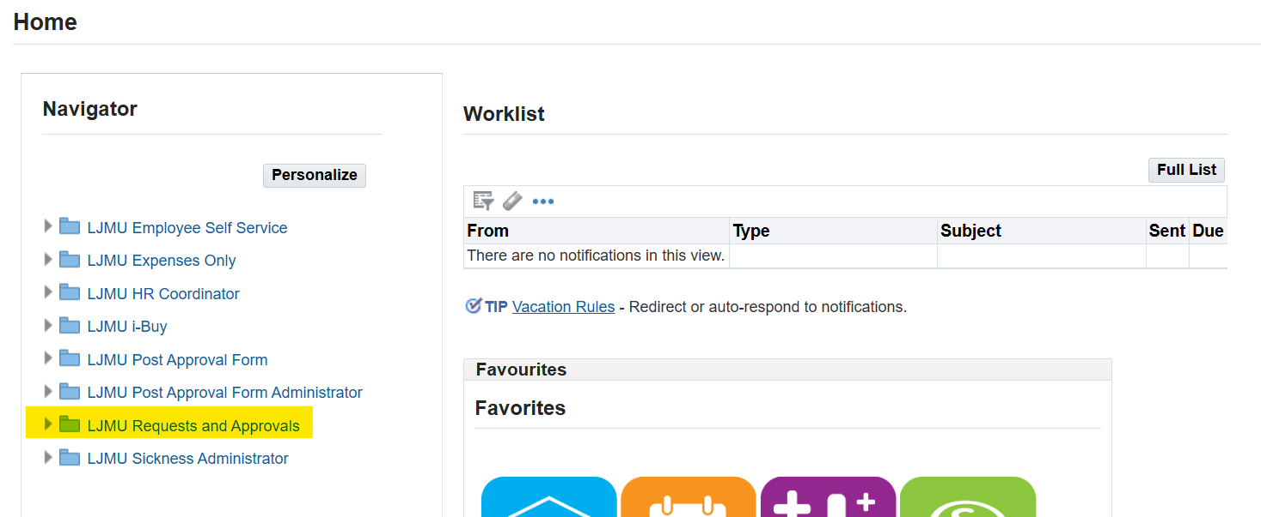

* Click through the following menu options:

**LJMU Requests and Approvals>HR>Contingent Worker Approval as shown below:**

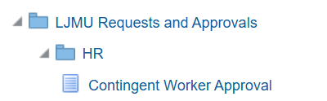

* Takes you through to the Submit a New Contingent Worker Approval page, then click on the ‘Submit a New Contingent Worker Approval’ button in the centre of the screen to start a new request:

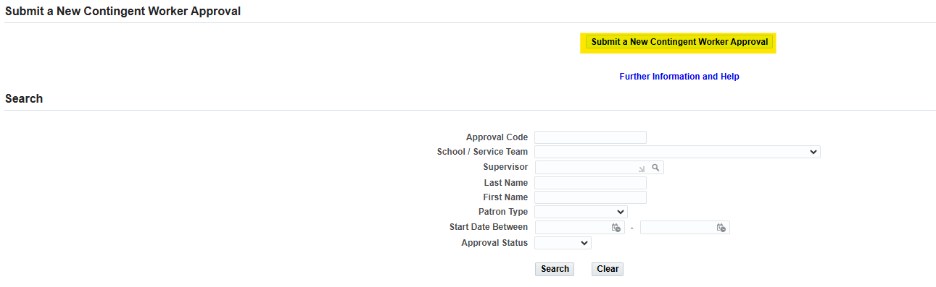

This then opens a form for the nominating employee to complete:

* All fields marked with an asterisk are mandatory and you will not be able to submit this form for approval without completing these fields.

**Line Manager section**

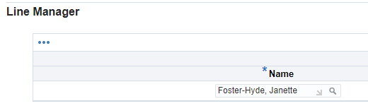

* The system will recognise the user completing the request and default in their details as the Line Manager.
* Alternatively, you can select a different line manager using the search option in the ‘Name field’. Please ensure you select the correct person.
* It automatically populates the Job Title and School/Service Team of the Line Manager.

**Position section**

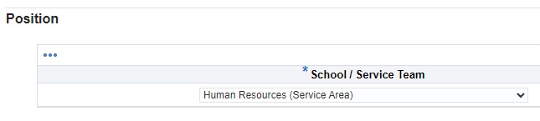

* State which team you require this new contingent worker position to be created.
* The ‘patron type’ is which category this worker would fit under, additional information can be found in our [guidance](https://ljmu.ac.uk/staff/hr/visitors-and-honorary-visitors-guidance/general-guidance) pages.

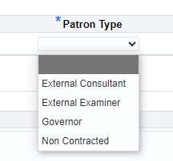

* **Note:** The Governor patron type can only be submitted by Secretariat department.
* If selecting Non Contracted then there is an additional field to complete that will pop down:

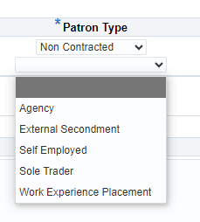

* Specify the job type using drop down options:

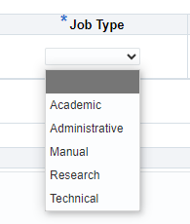

* The **start date** should be at least 2 working days ahead to allow time for the request to progress through the approval route. Human Resources will require a minimum of 2 working days notice to action the authorised request for IT access.
* If the contingent worker request is submitted on the same day as the start date, then please be aware there is no guarantee access will be available due to the requirement for approval/HR confirmations. It also takes approximately 3 hours to create a new email address and account for the new contingent worker via all LJMU systems.
* The **Reason for Request** is mandatory for you to specify the exact nature of the role and why access is required. The approver will have access to this information, so please provide sufficient information in this section.

**Contingent Worker Details section**

Enter all personal details including contact details for the new contingent worker (fields required are detailed in the [[guidance](https://ljmu.ac.uk/staff/hr/visitors-and-honorary-visitors-guidance/general-guidance)](https://ljmu.ac.uk/staff/hr/visitors-and-honorary-visitors-guidance/general-guidance) for you to copy into an email to request from the new contingent worker)

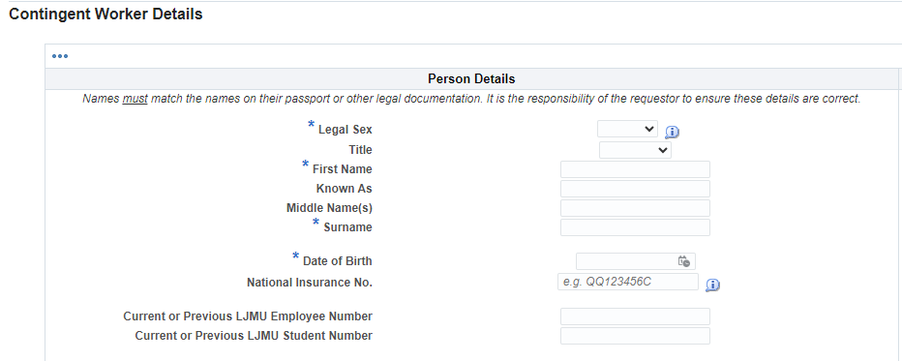

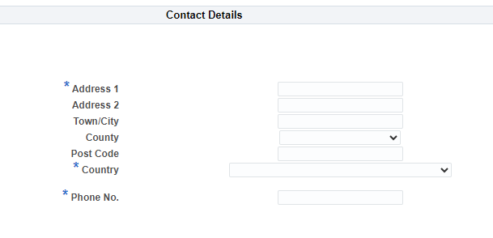

**Right to Work section**

Please read the ‘Further details’ link on the form if required regarding documentation. Alternatively, you can contact your HR Business Partner.

**Notes to Approver section**

This section is to advise the budget holder of any resources that are required for the contingent worker, you will still need to arrange the relevant resources once your request is approved.

**Submitting the request**

* Agree you have read the guidance before clicking on ‘Submit’ and understand your responsibilities.
* As long as there are no data errors or any mandatory fields missing then the request will confirm it has been ‘submitted’ and the approval process started.
* Once submitted you cannot amend or withdraw the request.
* You can search for the request at any time to review its status, please note you can only search requests that you have created.

**Step 2 – Approval Process**

Email/workflow notifications get sent to the Approver(s).

Approvers are Director of School/Service and Heads of Operations in Faculties.

The HR Team then perform a final data check before the contingent worker request is loaded into Staff Infobase.

**Important**: After the HR step, the account creation can take up to 3 hours via the cloud to ensure access to LJMU systems.

Please note:

* If an Approver is on leave, then providing they have set their Vacation rules in Staff Infobase, the Approval process will flow smoothly.
* If the Approver does not set Vacation rules, the request will remain in their notifications and will not automatically escalate after a defined period.
* The Approver should ensure they set their vacation rules to someone with appropriate authority to approve on their behalf.
* The Approver will be notified both by email and on their Worklist in Staff Infobase that a contingent worker request requires approval.

**Step 3 – Start day (Day 1) of new contingent worker**

The line manager identified on the form will receive an automated ‘welcome email’ to give guidance and assist the new contingent worker regarding how to obtain an ID card (if required) and activating IT access.

Any queries relating to access on the start date should be directed to the **IT Helpdesk on 0151 231 5555.**