# [Image result for liverpool john moores university logo](https://www.google.co.uk/url?sa=i&rct=j&q=&esrc=s&source=images&cd=&cad=rja&uact=8&ved=0ahUKEwjZuerSu4nXAhWGchQKHbT9CwIQjRwIBw&url=https://www.eventbrite.co.uk/o/liverpool-john-moores-university-roscoe-lectures-3233158788&psig=AOvVaw2rEDE_dQz3fMXV7J1A9n9g&ust=1508941556822069)Process Document

**CRM – Student Advice & Wellbeing**

Liverpool John Moores University

**SAW Finance Team**

**Processing a Funding Enquiry**

Version 0.2 November 2018

Author: DS Business Support Team

**Contents**

1. **Converting Email to an Enquiry**
2. **Creating a Funding Enquiry from Enquiries screen**
3. **Processing the Enquiry**
   1. Acknowledge
   2. Resolution
4. **Converting an Enquiry from an Email**

* Open up Email from Queue.
* Click on three dots (Elipsis)

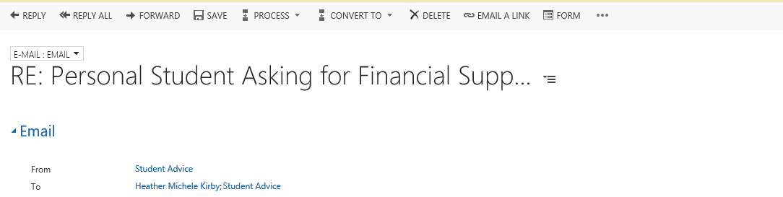

* Click on Convert to Enquiry

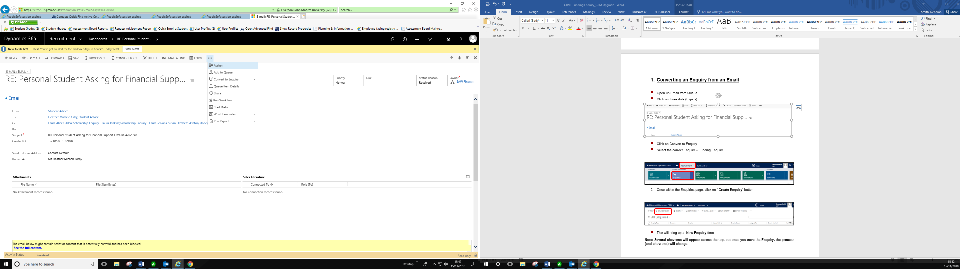

* Select the correct Enquiry – Funding Enquiry

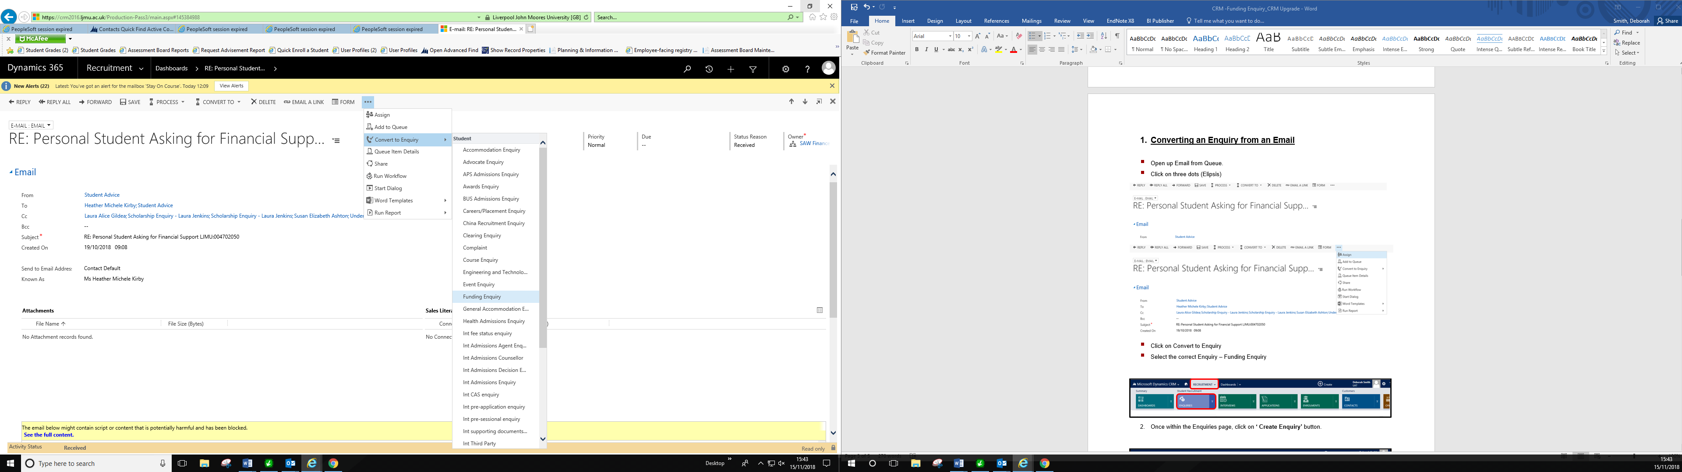

1. **Creating a Funding Enquiry from Enquiries screen**

* Navigate to Recruitment
* Click on Enquiries

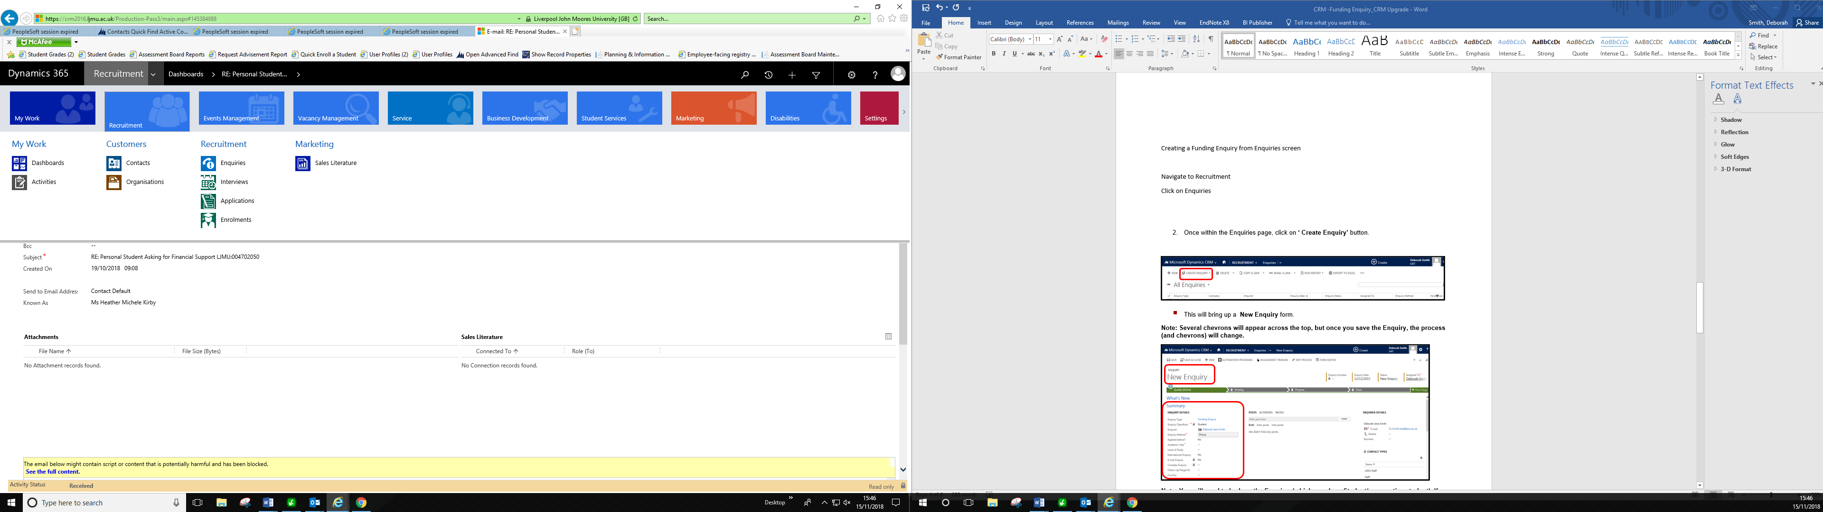

* Once within the Enquiries page, click on **‘ Create Enquiry’** button.

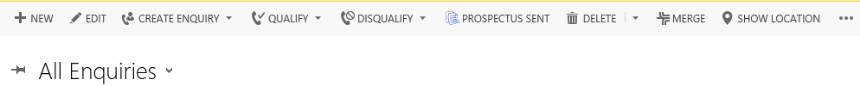

* This will bring up a **New Enquiry** form.

**Note: Several chevrons will appear across the top, but once you save the Enquiry, the process (and chevrons) will change.**

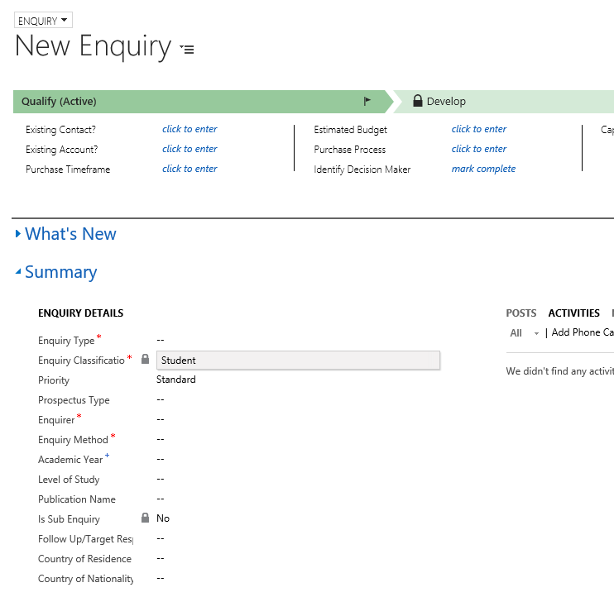

**Note: You will need to look up the Enquirer (which may be a Student/prospective student). If a Contact is not found, you may need to set up a Contact record. Please refer to Creating a Contact for further information.**

**Note: You can use the wildcard function (an asterisk - * ) to search for a Contact**.

* You will also need to select the **Enquiry Method**.
* **Click Save.**

1. **Processing the Enquiry**

You will note that the Enquiry is now made up of two chevrons:

* **Acknowledge**
* **Resolution**
  1. Acknowledged

Within the Acknowledge chevron, you will need to complete:

* **Enquiry Acknowledged**
* **Date Acknowledged**

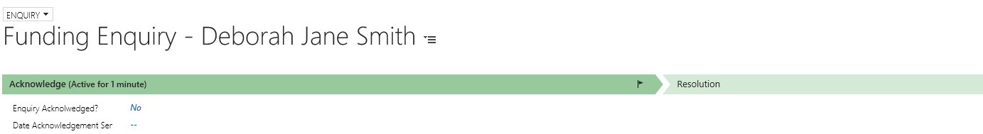

* 1. Resolution

Fields to be completed are:

* **Resolution-** Yes/No
* **Date Enquiry was Resolved-** Select date
* **Resolved by-** Will default to user creating the case, but you can change using the User Look up
* **Resolution Details-** Free Text Field
* **Resolution Category-** Drop Down
* **Close Enquiry-** No. This should always remain as ‘No’.
* **Status (top right hand corner)-** Amend Status to **Resolved**

