**[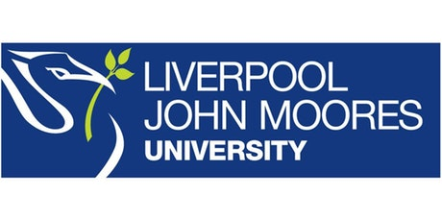](https://www.google.co.uk/url?sa=i&rct=j&q=&esrc=s&source=images&cd=&cad=rja&uact=8&ved=0ahUKEwjZuerSu4nXAhWGchQKHbT9CwIQjRwIBw&url=https://www.eventbrite.co.uk/o/liverpool-john-moores-university-roscoe-lectures-3233158788&psig=AOvVaw2rEDE_dQz3fMXV7J1A9n9g&ust=1508941556822069)**

**Process Document**

**CRM – Outreach**

Liverpool John Moores University

**Outreach: Mailbox Enquiries**

Version 0.1. November 2018

Author: Debbie Smith Business Support Team

**Dealing with emails in Dynamics**

The Outreach Team receives email enquiries from three public email addresses; Outreach, StudentAdvocates1 and NIOutreach. Responsibility for checking these inboxes is allocated on a rota basis to the Outreach Assistants (OA’s) within the team.

Emails coming into the Outreach Dashboard are generally actioned in one of four ways:

1. **Converted to an enquiry**

Emails which can be responded to by the OA’s are converted to an enquiry and categorised as either; School Enquiry, Advocate Enquiry or Summer University Enquiry.

The enquiry is then acknowledged and usually a response would be sent via email. Details of the resolution are then entered into Dynamics. *NB the enquiry should not be set to ‘Closed’*

Examples of the above include:

* General emails from Student Advocates (NOT responses to job bulletins)
* General emails from schools which don’t require an Account Manager to reply
* General emails about Summer University / Shadowing / Outreach Projects.

1. **Re-assigned to another department**

Emails which cannot be responded to by the Outreach Team are converted to any of the relevant enquiry types within Dynamics. Depending upon the enquiry type, this might automatically assign it to a different department within the University and details of the resolution can be entered, as above.

Examples of the above include:

* Emails which require responses from the CRM Team / Accommodation Team / Student Advice & Wellbeing / International / Faculties

1. **Forwarded to a member of the Outreach Team**

If the enquiry needs to be assigned to a specific member of the Outreach Team, this should be done by forwarding the email to the relevant member of the team via Microsoft Dynamics, after it has been converted into the relevant enquiry type. Details of the resolution should then be entered, as above, including the name of the Outreach Team who the email was forwarded to.

Examples of the above include:

* Emails from schools/colleges about events which are from one of our target areas
* Emails from schools/colleges which have a subject-specific enquiry

1. **Deleting the email**

If an email is clearly spam then it can be deleted directly from the Dashboard.