**[](https://www.google.co.uk/url?sa=i&rct=j&q=&esrc=s&source=images&cd=&cad=rja&uact=8&ved=0ahUKEwjZuerSu4nXAhWGchQKHbT9CwIQjRwIBw&url=https://www.eventbrite.co.uk/o/liverpool-john-moores-university-roscoe-lectures-3233158788&psig=AOvVaw2rEDE_dQz3fMXV7J1A9n9g&ust=1508941556822069)**

**Process Document**

**CRM – Outreach**

Liverpool John Moores University

**Outreach: Creating a Mail Merge**

Version 0.1. November 2018

Author: Debbie Smith Business Support Team

**Creating a Mail Merge in CRM**

There are two step-by-step guides which should provide most of the information (I have worked through them and managed to run a mail-merge)

1. **Outlook**

<http://www.magnetismsolutions.com/blog/colinmaitland/2014/02/04/how-to-create-a-mail-merge-template-for-a-custom-mail-merge-enabled-entity-in-microsoft-dynamics-crm-2013>

When the instructions make reference to ‘Microsoft Dynamics CRM for Outlook Client’ this is accessed through Outlook and by clicking on the Production Tab at the bottom of your screen

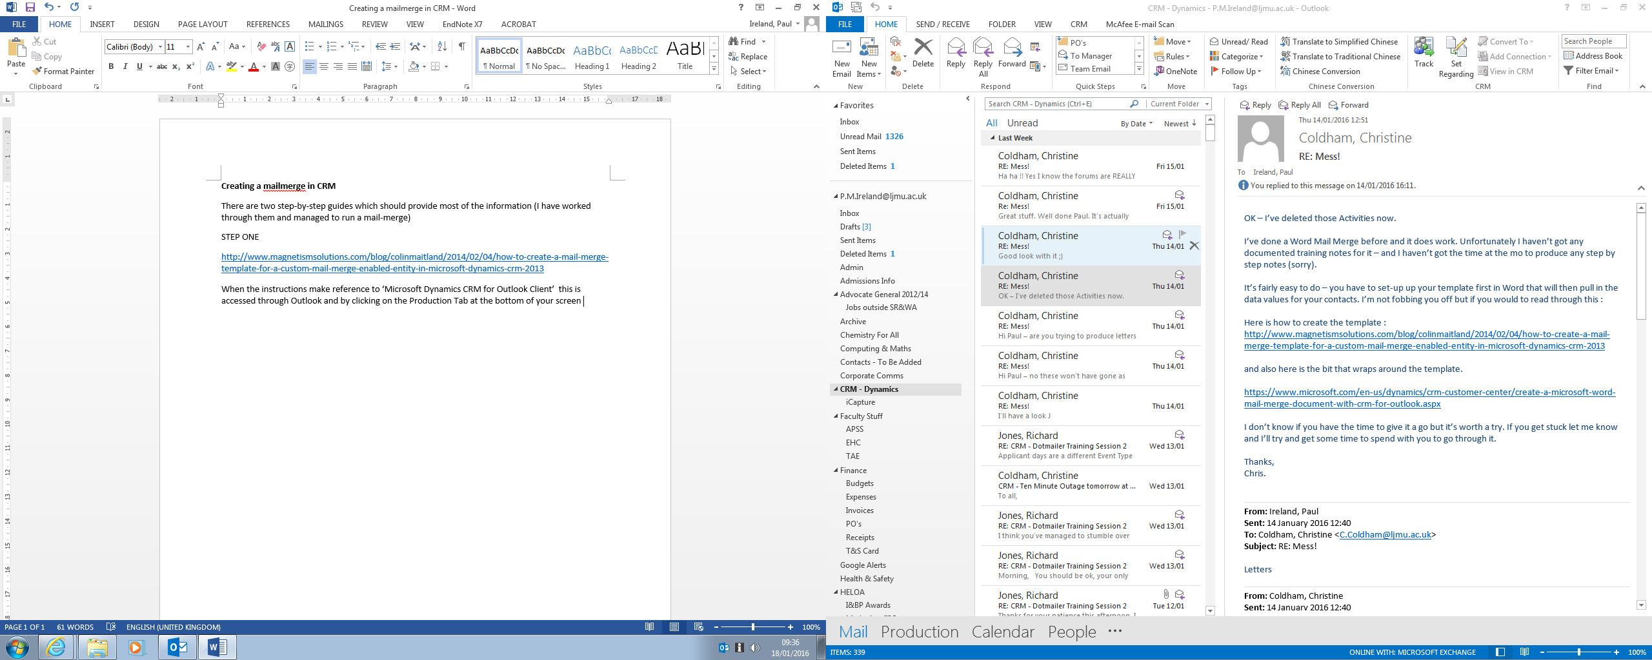  
  
When asked for ‘Associated Entity’ select ‘**Organisation’**

* For Data Fields, in general, that you need to add are:
* Record Type – Organisation
* Address 1: City
* Address 1: Street 1
* Address 1: ZIP/Postal Code
* Organisation Name

**Primary Contact**

* Record Type – Primary Contact
* First Name
* Job Title
* Last Name

The Mail Merge template should usually have been written already by the relevant Account Manager, so just copy and paste the text, at the relevant point.

1. **Completing the Merge**

The easiest way to complete the Mail Merge is by using the web-based version of CRM.

Select **Events Management > Marketing Lists**

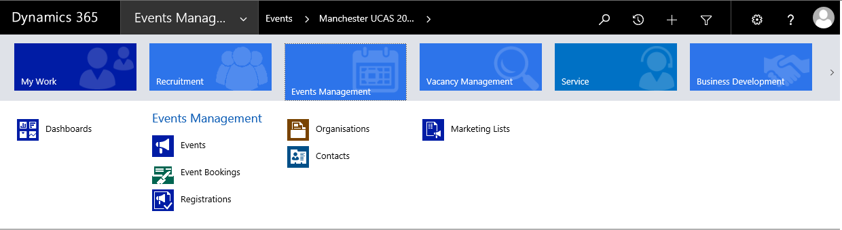

Next, select the relevant Marketing List for your mailout – If this hasn’t been set up, then speak to the relevant account manager.

* Click on the three dots
* Select Mail Merge on List Members..

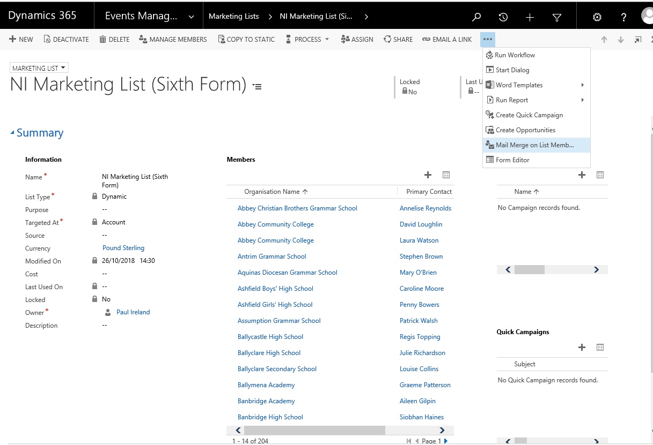

Once you have downloaded the mail merge, the following screen will appear.

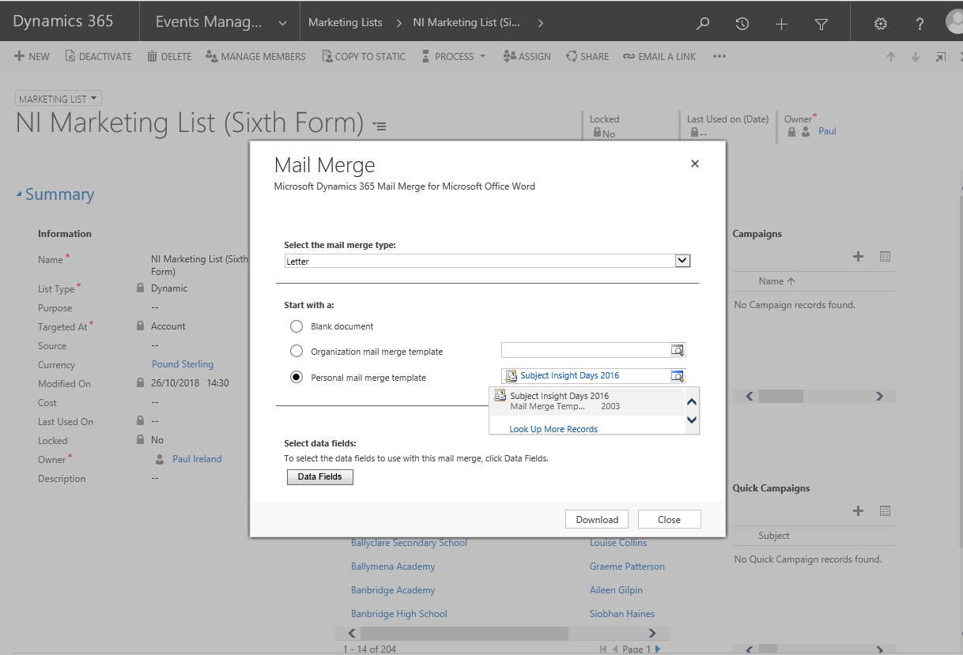Follow the instructions on the word document or else this video explains it <https://www.youtube.com/watch?v=AjZVVAhKZ1Y>

Make sure you record the activity as directed, the result is that it will be displayed on each of the Organisation Records who received the mail merge (see below)

