# [Image result for liverpool john moores university logo](https://www.google.co.uk/url?sa=i&rct=j&q=&esrc=s&source=images&cd=&cad=rja&uact=8&ved=0ahUKEwjZuerSu4nXAhWGchQKHbT9CwIQjRwIBw&url=https://www.eventbrite.co.uk/o/liverpool-john-moores-university-roscoe-lectures-3233158788&psig=AOvVaw2rEDE_dQz3fMXV7J1A9n9g&ust=1508941556822069)

# Process Document

# 

**CRM – Careers Team**

Liverpool John Moores University

**Careers Team: Events**

Version 1.1 November 2019

Author: Debbie Smith Business Support Team

**Version Control**

|  |  |  |
| --- | --- | --- |
| **Version 0.5** | **March 2018** | **Original Version** |
| **Version 0.6** | **Sept 2018** | **Changes to workflows**  **Introduction of QR codes for Employer Event/Fair Booking Confirmation & Reminder Emails.** |
| **Version 0.7** | **November 2018** | **Updated for the Upgrade to CRM 2016.** |
| **Version 0.8** | **December 2018** | **Updated s. 3.2 Wait List, point 3.** |
| **Version 0.9** | **January 2019** | **Added a Contributor section. s.4.3** |
| **Version 1.0** | **February 2019** | **Baselined** |
| **Version 1.1** | **November 2019** | **Added section 3.1 (adding a room to an existing venue)** |

**Contents:**

1. Careers Event Dashboard
2. Creating an Event
3. Adding an Event Venue
4. Delegate Management
5. Open Registration & Publish Event to Website
6. Booking an Event:
7. Via Website (Self Service)
8. Reviewing Booking Registrations in CRM
9. Registering Attendees Manually
10. Event Registration List
11. Employer Event/Fair
12. Event Changes & Cancellation
13. Completing an Event
14. Reporting
15. Workflow Emails

**Appendix 1: Career Event Workflows.**

**Related Process Documents: Searching for Contacts**

1. **Careers Event Management Dashboard**

* Each Team have their own Dashboard in CRM, which acts as a sort of Home page. The Careers Team Dashboard is called ‘**Careers Events Management’**.
* There are two views:
  + The top view will display **all present and future Careers Events** (Workshops/Webinar’s/Event Fair) which have been created in CRM.
  + The bottom view will display **all Career Events** ever created, including sessions held in the past with various ‘statuses’.

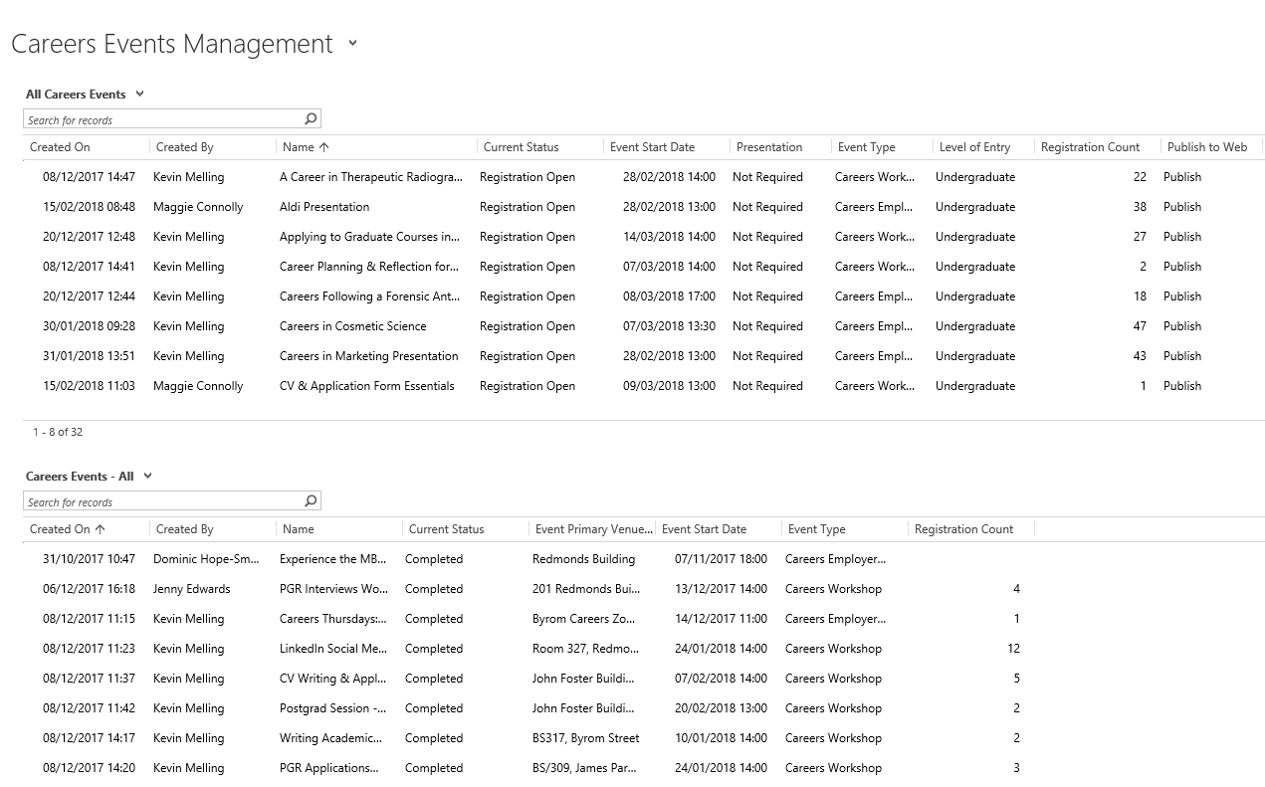

1. **Creating an Event**
2. To create an Event, you first need to select the Events entity.

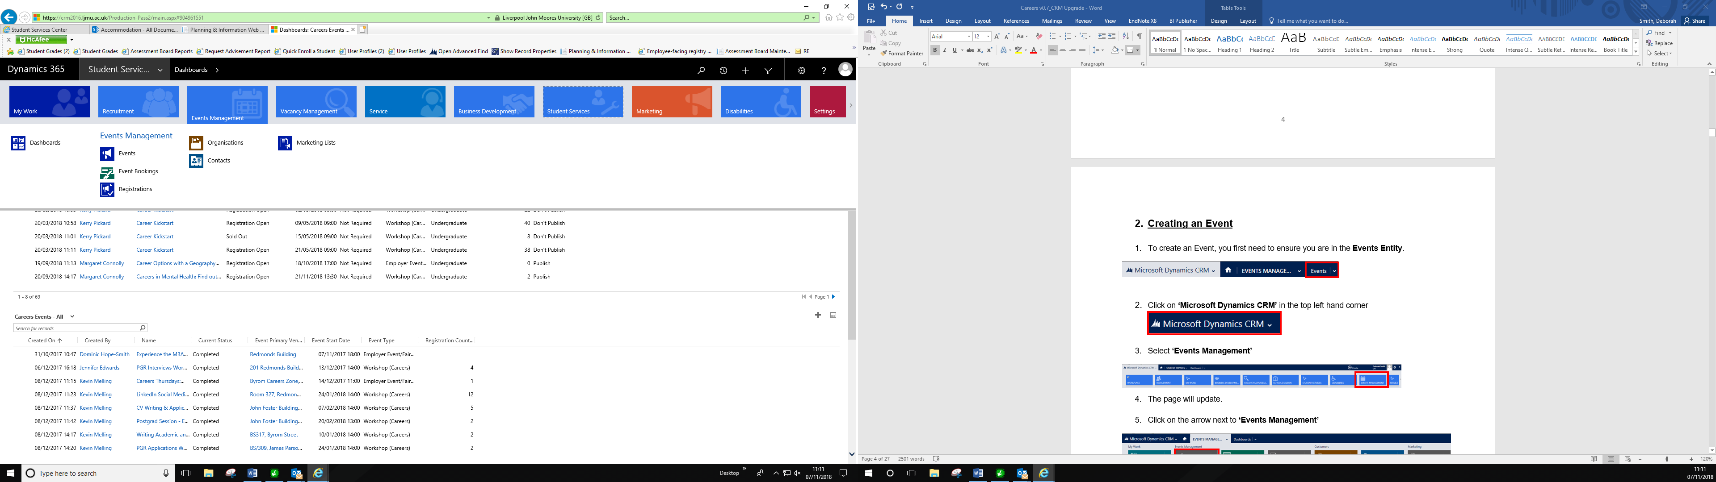

Then, click on **Events**

1. A page will appear called **‘My Campaigns’**. Once you have a number of Events set up, Campaigns you have personally created will display here.
2. In the top left hand corner, you will see 
3. Click here and a **New Campaign** page will open up.
4. Please check under ‘Save’ that it says **Campaign: Careers Events. If it doesn’t, click on the drop down arrow, and select Campaign: Careers Events.**

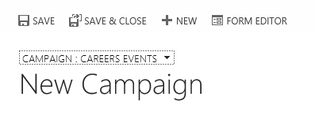

1. On this page, you will need to complete the following:

* **Name:** Enter the Name of the Event.
* **Current Status:** This will default to **‘Proposed’.**
* **Campaign Type**: Leave this as ‘Event’.
* **Event Type:** **Select Careers Webinar, Careers Workshop** or **Careers** **Employer Event Fair**
* **Event Start Date:** Enter the Date of the Event and Start Time
* **Event End Date:** Enter the Date of the Event and End Time.
* **Event Primary Venue:** Select the Venue which the Event is taking place.

1. To Look Up the Venue: Click on the magnifying glass icon. 
2. A few venue options will pop up, but if you scroll down to ‘**Look up more records’** a more detailed pop up box will appear to select the correct venue.
3. If the Venue is not set up, then please see section below called : **Adding an Event Venue** and follow the process through.
4. Select your Event Venue from the list, by ticking it on the left hand side.
5. Click **Add**
6. Click on Save at the top of the screen  Or
7. Click on the **‘Save’** icon at the bottom right of the screen 
8. Once Saved, you will notice the Name of the Event will appear in the top left corner.

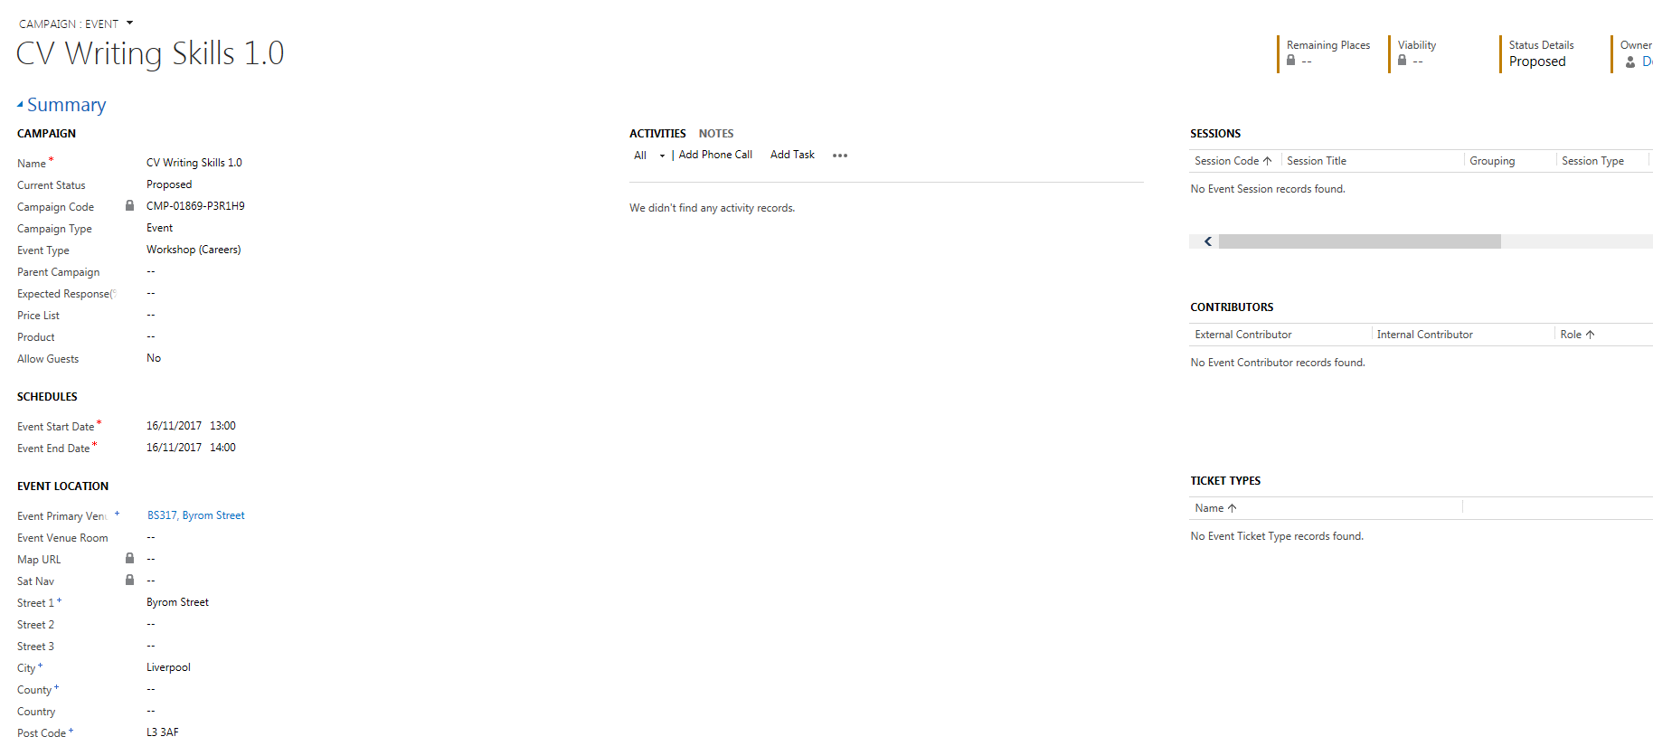

1. **Adding an Event Venue**
2. Click into **Event Primary Venue** field
3. Click on **Look Up**
4. Scroll to **Look up** more records

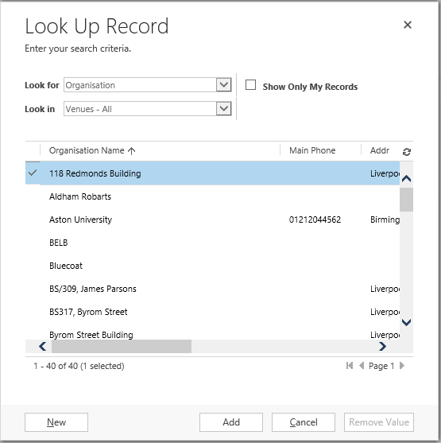

1. Click **New**
2. A new window will open up.
3. Change the drop down box below Save & Close to **Organisation: Venue**

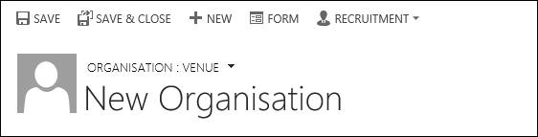

1. Complete the **Organisation Name** – for LJMU buildings include here the Room Name & Building
2. Then, complete the **Address**.
3. Change the **Is a Venue** field to **Yes**
4. Click **Save**

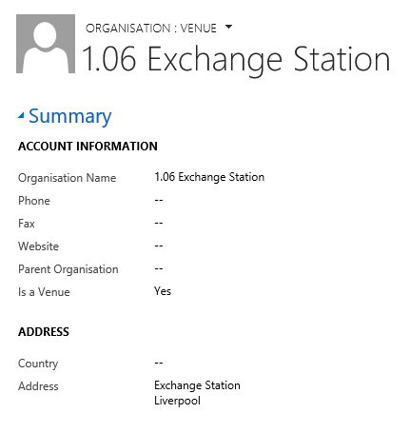

1. Click on the X to close the window.
2. Window asking you select a venue for your Event will still be open. The venue you have just created should now appear here for you to select by **ticking to the right** and clicking **‘Add’**

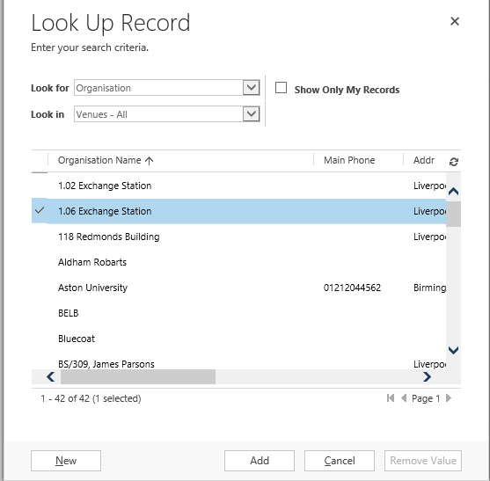

* 1. **Adding a Room to an existing Event Venue**
* Once you have selected the **Event Primary Venue** on the Event page, click on it.
* You will be taken to the **Organisation:Venue** page

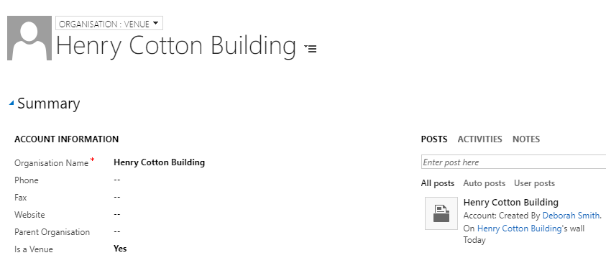

* Scroll down the page and to the right hand side you will see a section called ‘**Venue Rooms’.**

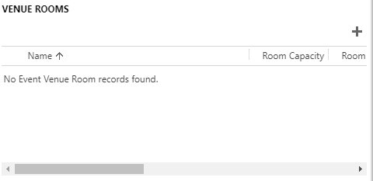

* Click on the **plus** icon.
* Complete the **Room Name**:

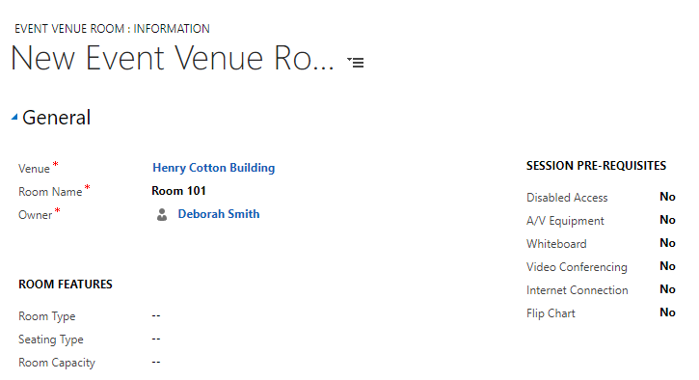

* Click **Save & Close**
* Navigate back to the Event and select the room you have created.

1. **Delegate Management**
2. Navigate to the Event Page.
3. Scroll down the page to **‘Delegate Management’**.
   1. **Manage Registration/ restrict numbers**.

Here, you can restrict the numbers attending the Event, and set up a **Waiting List**.

1. To restrict the numbers attending the Event, ensure there is a **‘Yes’** in the **Manage Registration** checkbox
2. Then, enter an amount into the **Maximum Event Capacity** field.

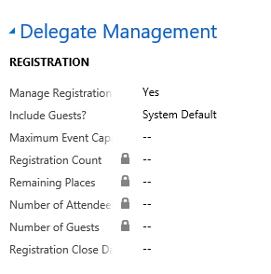

1. Click Save
2. The amount entered into the the **Maximum Event Capacity** field will be used to calculate **‘Remaining Places’** at the top of the Event Page.

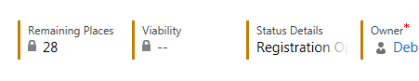

**4.2. Waiting Lists**

1. To add a Wait List to an Event, navigate to **‘Wait List’**.

2. Select **‘Yes’** in the Waitlist this Event field.

3. Next, click into **Waitlist Starting Point**, and add the number you wish the Waitlist to start at. This should be the **same** as the **Maximum Event Capacity**. E.g. If you have a capacity of 30, add 30 into the Wait List starting point.

4. **Save**

**If a Student is added to a Waiting List, then an Email will be sent to them via an automatic workflow. If a place does later come available, the ‘waiting list’ student will be emailed advising them that space has become available, and inviting them to book on to the Event.**

* 1. **Facilitators/Event Organisers**

You are now able to add facilitators/event organisers to a CRM event via the **‘Contributors’** function.

This section can be found on the main Event page to the right and is called called, **‘Contributors’**.

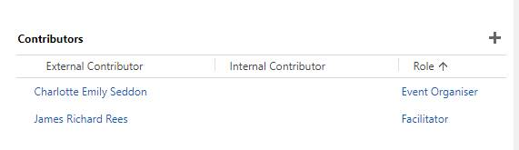

* + 1. **Adding a Contributor**

1. To add a **Contributor**, click on the plus **‘+’** icon.

2. This window will then display:

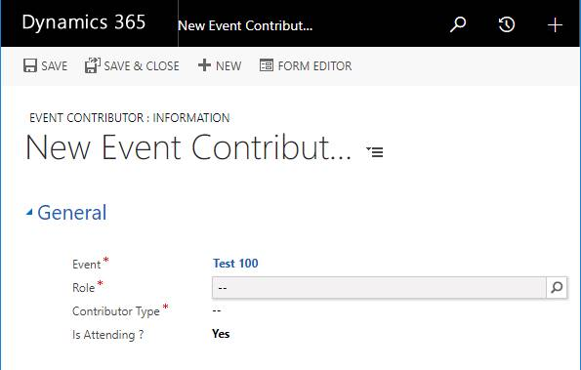

1. Click on the look up  within the ‘Role’ field
2. Select from either:

* **Facilitator**
* **Event Organiser**

1. This will set the contributor type and a new field will appear called **External Contributor:**

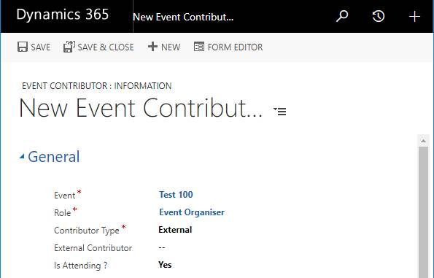

1. Click into **External Contributor** field look up.
2. A lot of names will appear, but you need to scroll right down to the bottom and click **‘Look up More Records’.**

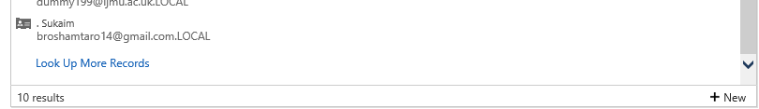

1. You can use the wildcard function where a middle name may be to help you search.
2. **The wildcard for searching in CRM is an asterisk (*).** So for example: ‘Deborah * Smith’

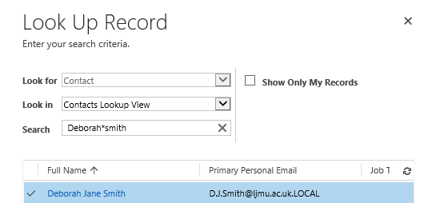

1. Select the correct contact by clicking to the left and a tick will appear.
2. Click **‘Add’.**
3. The name will now display in the **External Contributor** field.

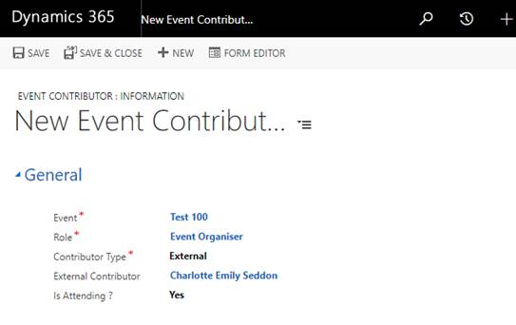

1. You can then click **Save** and **Close.**
2. The **Facilitator/Event Organiser** will appear in the **Contributors** panel on the main Event page.
3. **Open Registration & Publishing your Event to the Website**
4. Once all Registration Detail has been added to an Event, you are ready to make it Live & Publish to the Website.
5. Staying on the Event screen, scroll back up to **‘Event Details’**.
6. Navigate to the section called **‘Marketing’**

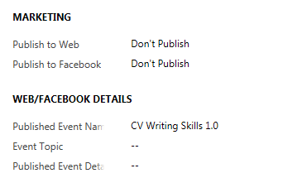

1. Change the Publish to Web field to **‘Publish’**
2. Click into the **Web/Facebook Details** section.
3. Navigate to **Published Event Details** field & enter a description/some detail about the Workshop/Webinar. **\*\*This detail will appear on the Website.\*\***
4. Next, in the **Event Topic** field, put the **Date** and **Start Time** for the Event. **You must enter this information as this will display on the Reminder Email which will be sent to all attendees.**

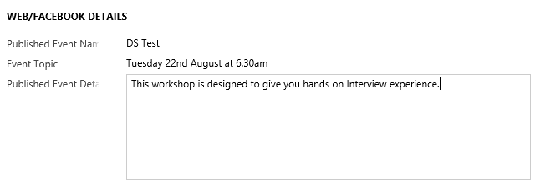

1. Click **Save**
2. Under **Event Details > Event Information**, find **Current** **Status.**
3. Change this from **Proposed** to **Registration Open.**

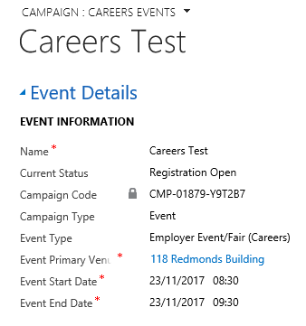

1. Click on the Save icon (bottom right) 
2. This Event is now live for students to book on to on the Website: https//careers.ljmu.ac.uk
3. **Booking on to an Event**
4. Students can book on to an Event in a number of ways:

* **Self Service: via the Website**
* **Booked on by Staff.**

1. When booked on to an Event an Email will be sent to the Student automatically. Please see details in ***Appendix 1***.
2. A reminder of the Event will also be sent 24 hours before the date and time of the Event.
3. **Self Service: via the Website**

The preferred option for booking on to an Event is for students to do it themselves via this web address:

**https//careers.ljmu.ac.uk**

1. Students will need to logon using their usual Credentials to gain access.

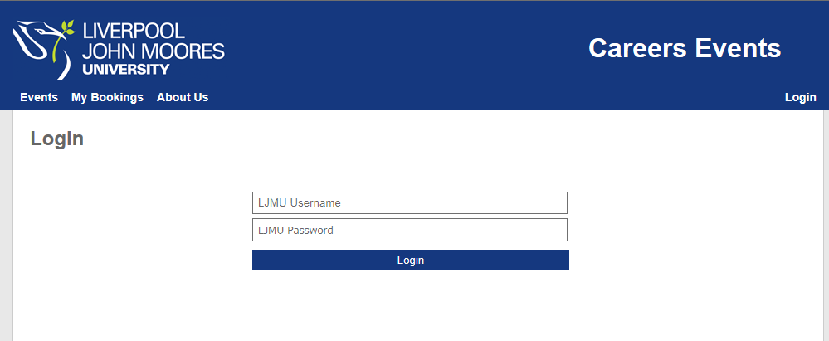

1. They will then be able to view all **Careers Open Event Registrations**.

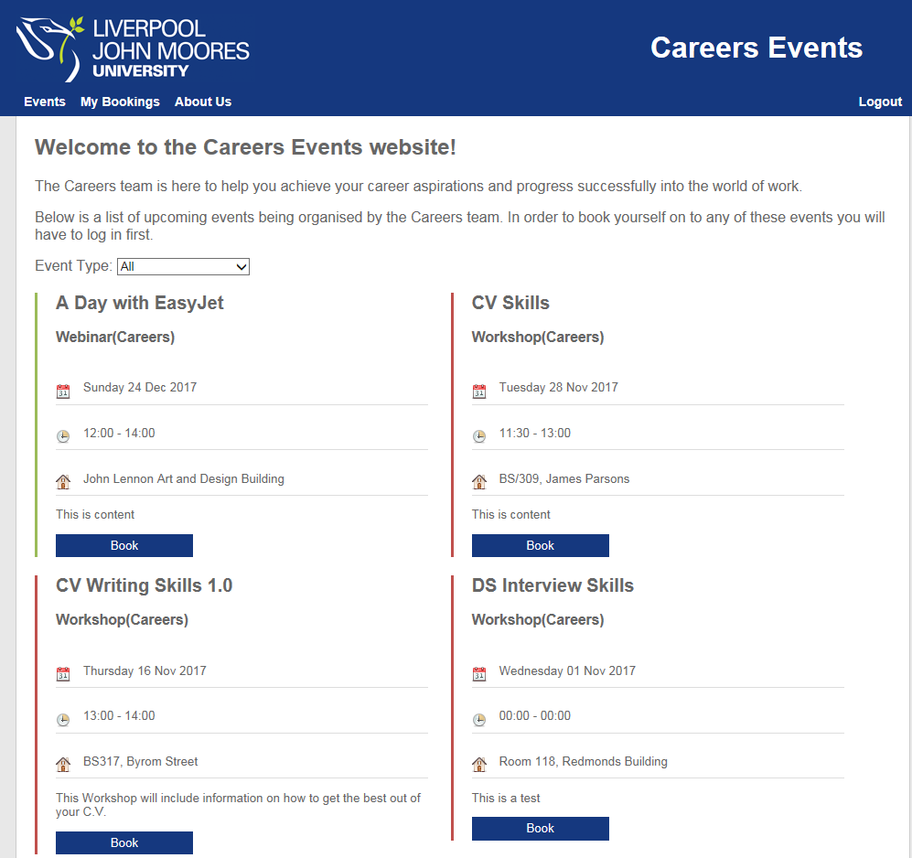

1. To book onto an Event, students will click the **‘Book**’ button.
2. Students will have the option to tick **‘Additional Support Required’** if necessary and enter details. Please refer to **‘Reporting’** for details on how to view these Additional Support Requirements in CRM.
3. Then click on **‘Confirm Booking’**
4. They will receive a pop up to tell them that their Booking was Successful. This Event will now also appear under **‘My Bookings’**
5. **The student will receive an Email (which is sent from CRM) confirming that they have booked on to the event. Please see Appendix 1: CRM Email Workflows**

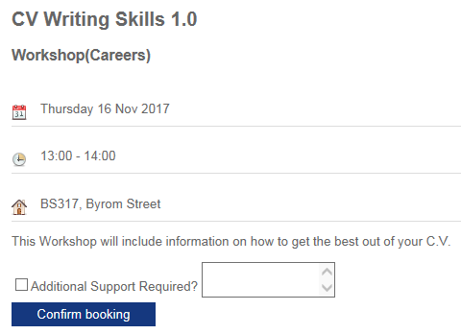

1. Attendees can also cancel a booking on the website via **My Bookings**. This will remove them from the event in CRM – although you will still be able to see that they booked on the event originally.
2. **Reviewing Booking Registration in CRM**
3. Back in **CRM**, on the Event Page, you are able to review who has booked on to an Event, within the ‘**Bookings’** section.

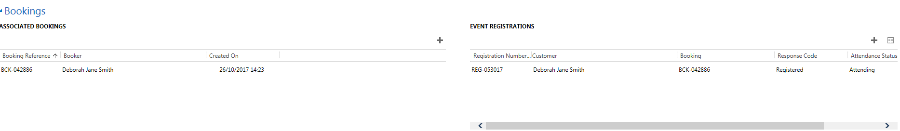

1. All Bookings will appear under ‘**Event Booking’**. This includes if any Bookings have been cancelled. All Active Bookings will appear under **Event Registrations.**
2. **Adding Students on to an Event Manually**

You may need to manually add a student on to an event if they turn up on the day/or have issues via the website. You can do this via the Event.

**Once you have added the student, then an Email will be sent to the student automatically from CRM confirming the Booking.**

**A reminder email will also be sent 24 hours prior to the date & time of the Event.**

* 1. **…via Event**

1. Navigate to your Event Booking.
2. Scroll down to **‘Bookings’**

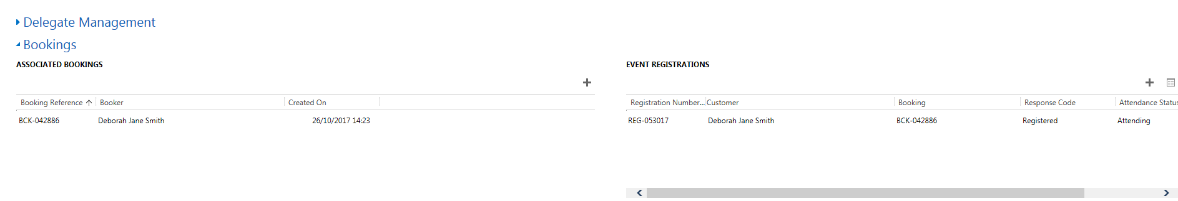

1. Where it says ‘**Event Registrations’** click on the ‘+’.

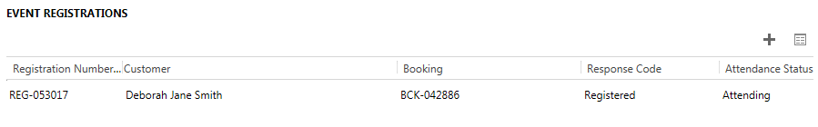

1. **‘New Campaign Response’** box will open
2. **Ensure that the header above ‘Campaign Response is set to Campaign Response: Attendee by clicking on the downward arrow.**

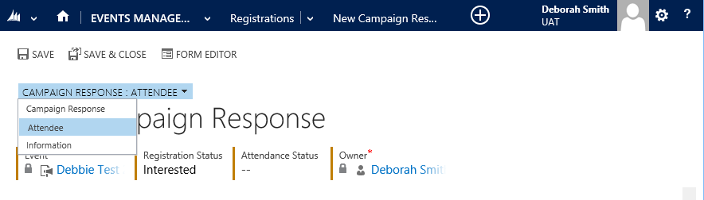

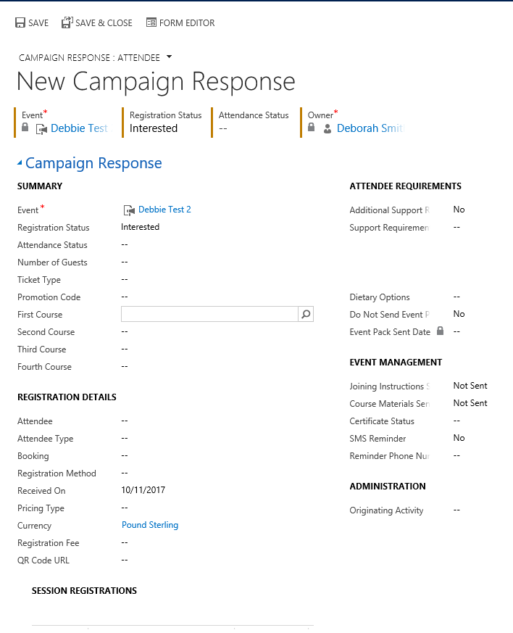

**3**

**4**

**2**

**1**

1. Click into the **Registration Status field**, andselect **Registered (1)**
2. Next, click into the **Attendance Status field** and select **Attending**
3. Navigate to the **Registration Details section (2)**
4. Click into the **Attendee** field and search for the student.
5. You can search for the student by using the **wildcard * or by student ID number.**
6. **Once you find the student, click the ‘tick’ to the left of their name and then ‘Add’.**
7. **If the student has any Additional Support Requirements**, navigate to **Attendee Requirements** and complete relevant boxes. **(3)**
8. If the Student would like an **SMS reminder,** then navigate to **’Event Management’, SMS Reminder. (4)**
9. Make sure you **Save**!
10. **Event Registration Lists**
    * + 1. You can export a list of Registered Students for each event on CRM to enable you to tick off who has actually attended. To do this you, must run a report.
        2. At the top of the screen, click on to **the button next to Dynamics 365 button.**
        3. Click on the downward arrow to the right.
        4. Ensure ‘My Work’ is selected

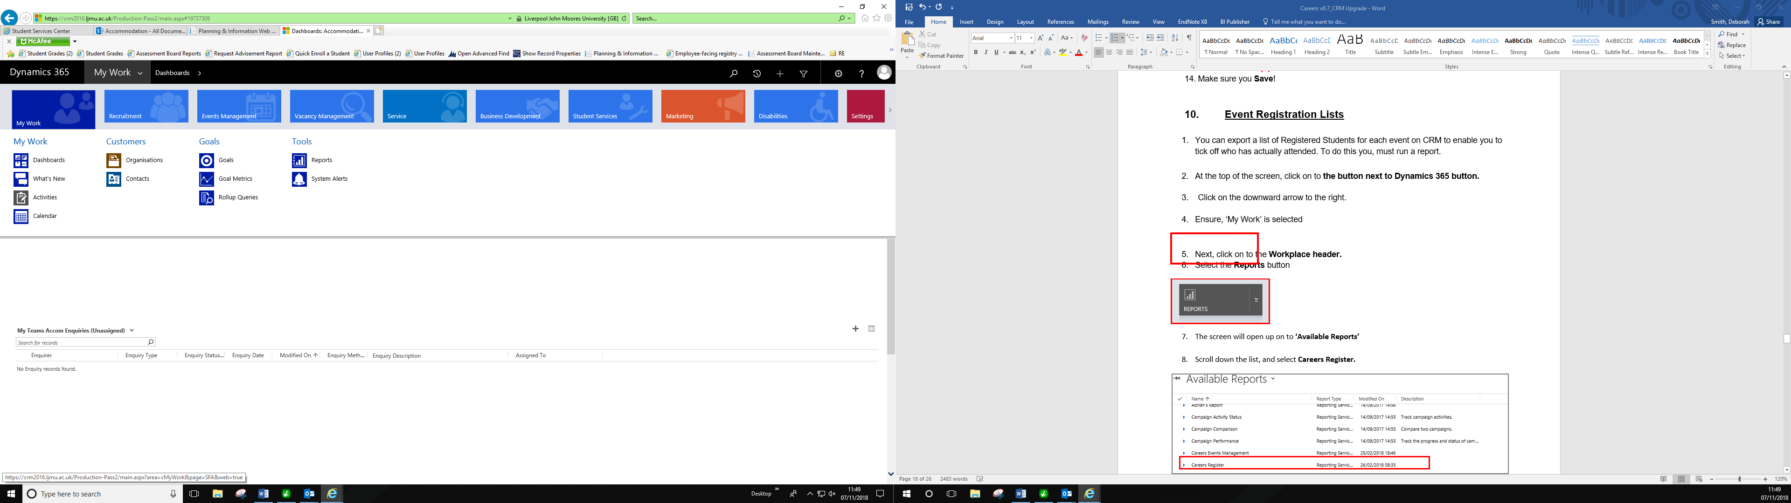

* + - 1. Select the **Reports** button under Tools

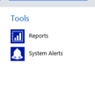

* + - 1. The screen will open up on to **‘Available Reports’**
      2. Scroll down the list, and select **Careers Register.**

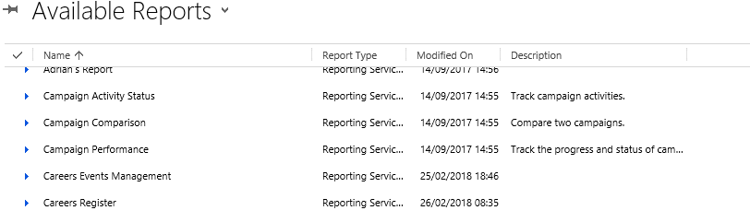

8. The **Careers Register** will open up at the top of the screen.

9. You will need to search for the Event which you wish to view the Registrations for at the top, under **‘Campaign Id’**

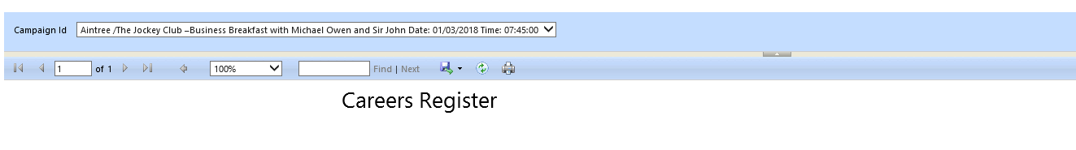

You can then Save or Print this information.



1. **Employer Event/Fair**

* For ‘**Employer Event/Fair’** Event Types, **Booking Confirmation** and **Event Reminder** emails (sent 24 hours before commencement of event) will contain a **QR code**.
* Attendees will need to show the QR code to the facilitator when registering on the day.
* This code can be scanned by any device with a QR Reader.
* This will then automatically mark the Campaign Response in CRM as ‘**Attended’.**

**The email containing the QR Code will look like this:**

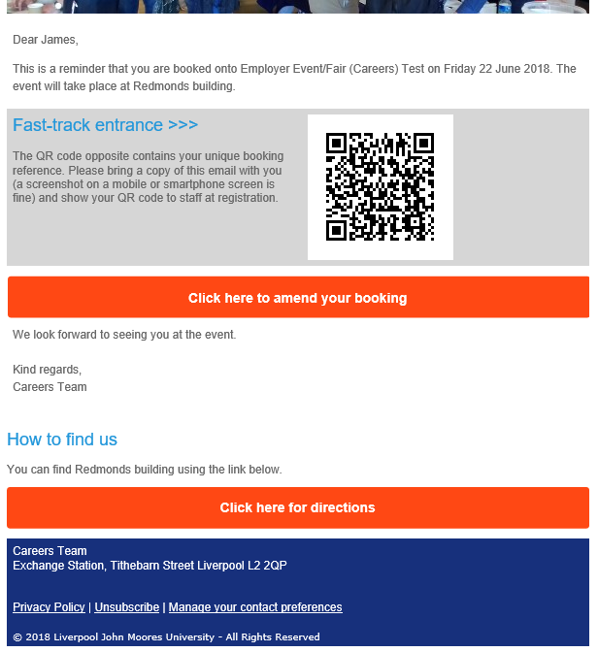

1. **Event Changes & Event Cancellation**
   1. **Event Changes**

If an Event has:

* A Date Change
* A Time Change
* Date & Time Change
* Location Change

You can do this by just updating the ‘Event Page’ and clicking Save.

**Once these changes have been updated in CRM by a member of staff, an Email will be automatically sent to all Attendees advising them of the changes.**

* 1. **Cancelling a Student’s Event Booking**

A student may cancel their booking via the Website, this is the easiest and preferred option! However, a member of Staff may cancel an Event on a student’s behalf.

You can cancel a student’s Event Booking by scrolling to **Bookings**.

1. Navigate to the right hand table ‘ **Event Registrations’**
2. Locate the Student from the list
3. Click on the **Registration Number, it will start with ‘REG –‘**
4. The Campaign Response screen will update.

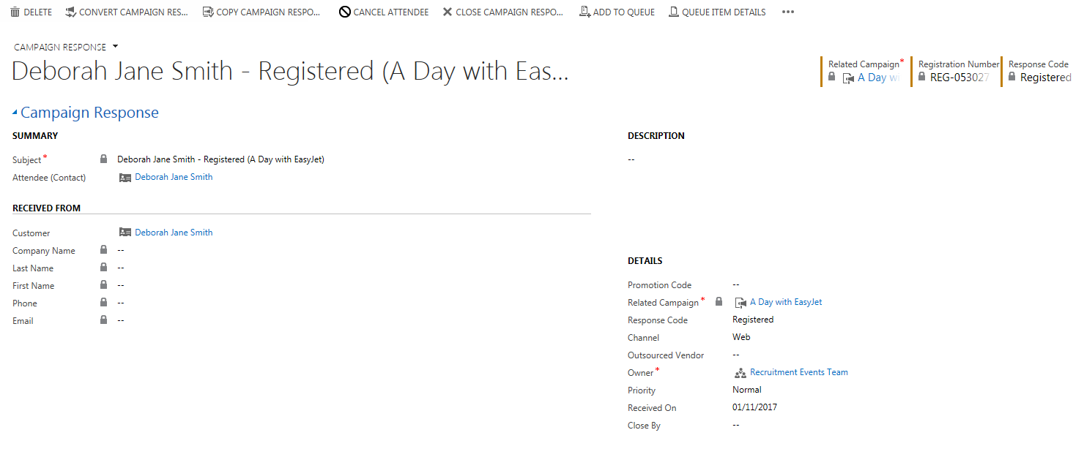

1. Along the top of the screen, you will see ‘Cancel Attendee’ button.



1. Click here, and a **‘Cancel Attendee’** window will open up.
2. Click ‘**Yes’**, as this to ‘**Refund Event Fee’s’**.
3. Click **‘Next’**

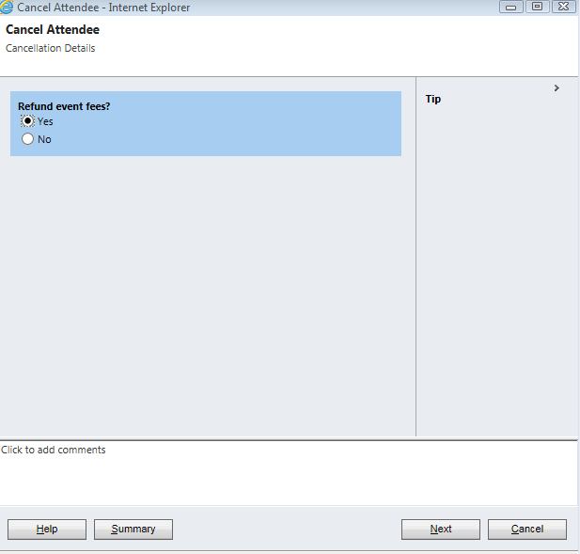

1. Click **‘Finish’**

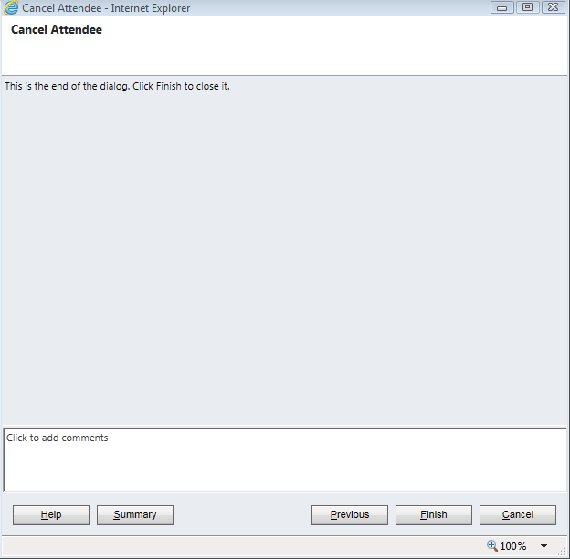

1. You will note that the status has now changed from **‘Registered’** to **‘Registration Cancelled’**.

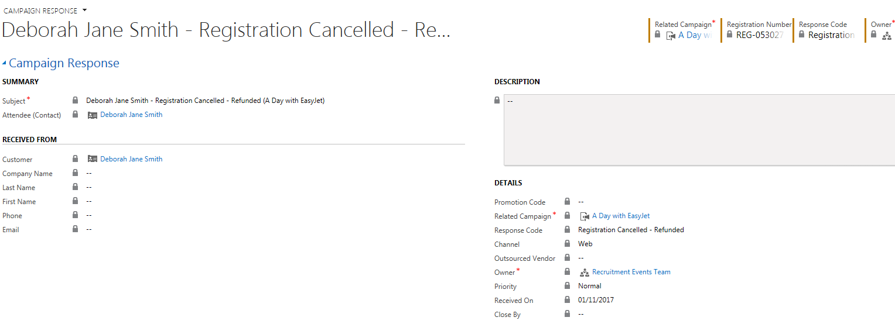

* If you head back to the Event Page
* Navigate to **Bookings** section
* You will note that the students name will no longer appears under Event Registrations. The students name will still appear under Associated Bookings.

**Once a student’s booking has been cancelled, then an email will be sent to the student automatically.**

* 1. **Cancelling an Event.**

1. Navigate to the Event Page
2. Click into **Current Status**
3. Update this to **‘Cancelled’**
4. Click **Save.**

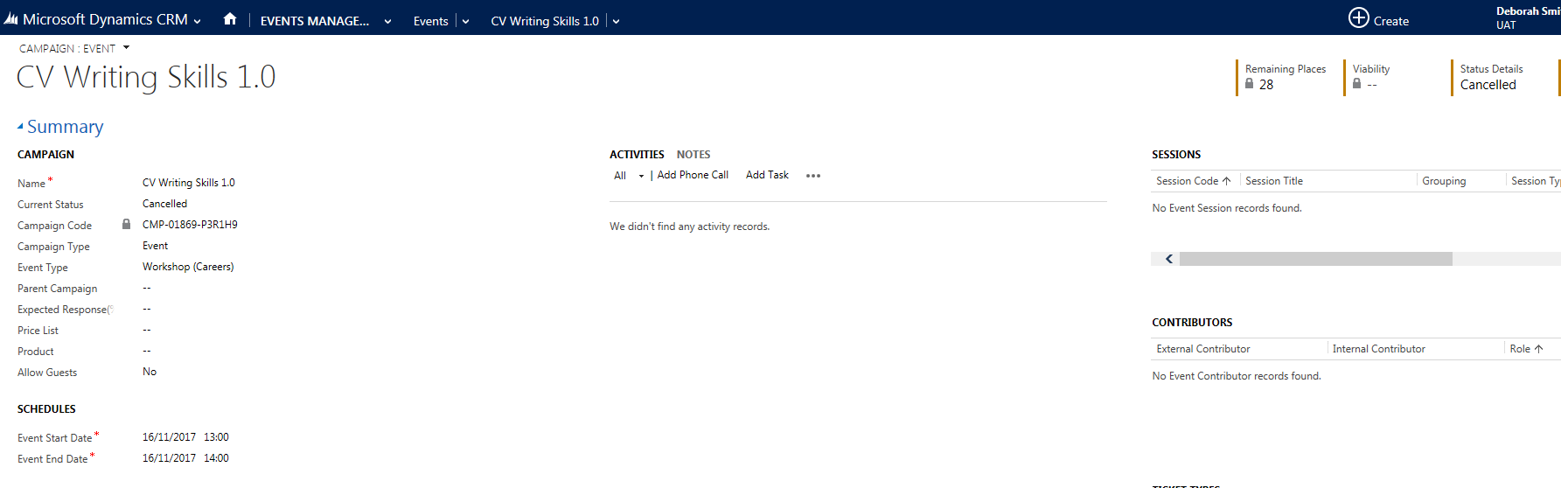

**An Email will be sent to those registered as attending, advising them of the Booking Cancellation.**

1. **Completing an Event**

Once an Event has been held, all attendees have been added either automatically or manually, you will need to mark the attendees as ‘Attended’ so that the **Post Survey Email** can be sent out (7 days after the Event).

1. To do this, click into the Event & navigate to Bookings
2. Click into the Event Registration page & ‘pop out’.
3. To the left of **‘Subject’** you will see a tick column.
4. You can tick all of those who have Attended/ or those who did not show up, e.g. ‘No Show’.
5. **\*\*Important** Students attending an Employer Event/Fair will automatically have their campaign response set as ‘Attended’ IF their QR code was scanned.**
6. **\*\*Important: The Post Event Survey will be sent to all Students who are marked as Attended 7 days after the date of the Event\*\***
7. Next, you need to **Complete the Event**.
8. From the Event page, change the **‘Current Status’** to **Completed**.
9. Click on the ‘**Save’** Icon.

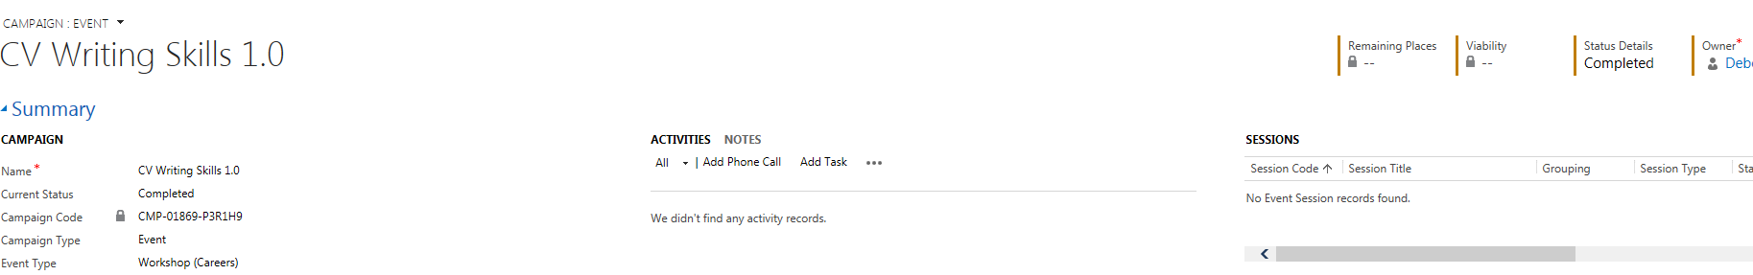

1. **Special Requirements Reporting**

An Email will be sent to you to inform you if a student has specified Special Requirements. If you wish to see this as a list, you can access a report within CRM.

1. To run the report, navigate to your Event Page.
2. Scroll to Bookings
3. Pop Out the Event Registrations 

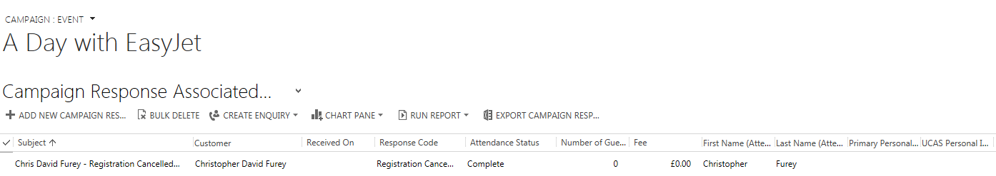

1. Click on the downward arrow underneath your Event Name

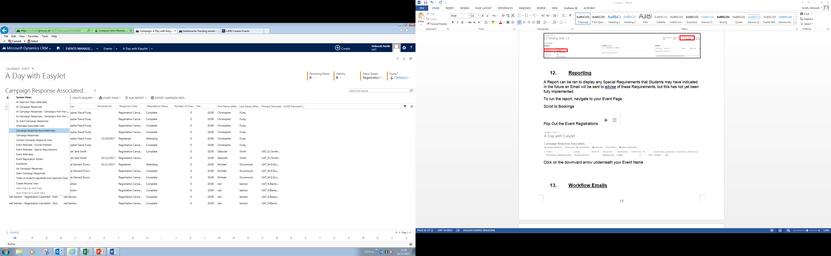

1. Select **‘Event Attendee – Special Requirements’**
2. This will detail all Attendees who have indicated a Special Requirement. The details can be found under ‘Support Requirements.

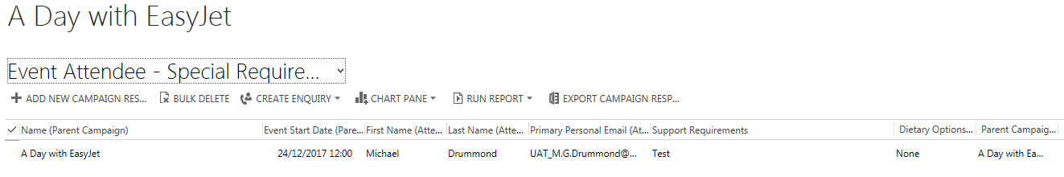

1. **Workflow Emails**

A number of Workflows have been created within CRM to send emails automatically at different stages of the Event process. More details on what the email text is etc., can be found in a separate document Appendix 1.

These emails will be sent from a separate email created solely for the purpose to send CRM emails: [CareersEvents@ljmu.ac.uk](mailto:CareersEvents@ljmu.ac.uk). Students will be urged not to reply to this email, but if they do, replies will be re-routed to Careers@ljmu.ac.uk

The workflows are:

1. **Booking onto an Event**
2. **Reminder of an Event**
3. **Event Change**
4. **Unbooking from an Event**
5. **Event Cancellation**
6. **Post Event Survey**
7. **Event full – on a waiting list**
8. **Event full – on a waiting list and place becomes available.**

Any changes to Workflows, need to be requested via Helpdesk.