**[](https://www.google.co.uk/url?sa=i&rct=j&q=&esrc=s&source=images&cd=&cad=rja&uact=8&ved=0ahUKEwjZuerSu4nXAhWGchQKHbT9CwIQjRwIBw&url=https://www.eventbrite.co.uk/o/liverpool-john-moores-university-roscoe-lectures-3233158788&psig=AOvVaw2rEDE_dQz3fMXV7J1A9n9g&ust=1508941556822069)Process Document**

**CRM – Careers**

Liverpool John Moores University

**Careers SIO View**

**Dashboard**

Version 0.1, January 2021

Author: DS Business Support Team

**Contents**

1. Locating Your Dashboard
2. Pinning a Dashboard
3. Views – Pop Out Function
4. Sorting
5. Careers SIO View Dashboard

# Locating your Dashboard

Each Department who use CRM have their own dashboard, which normally acts as a ‘home’ page. The **‘Careers Case Management’** Dashboard has been split into 5 views to help manage emails and cases.

Next to Dynamics 365, there will be an Entity Name. e.g. My Work/Student Services

• Click on the downward arrow

next to Entity Name

• Select ‘Dashboards’

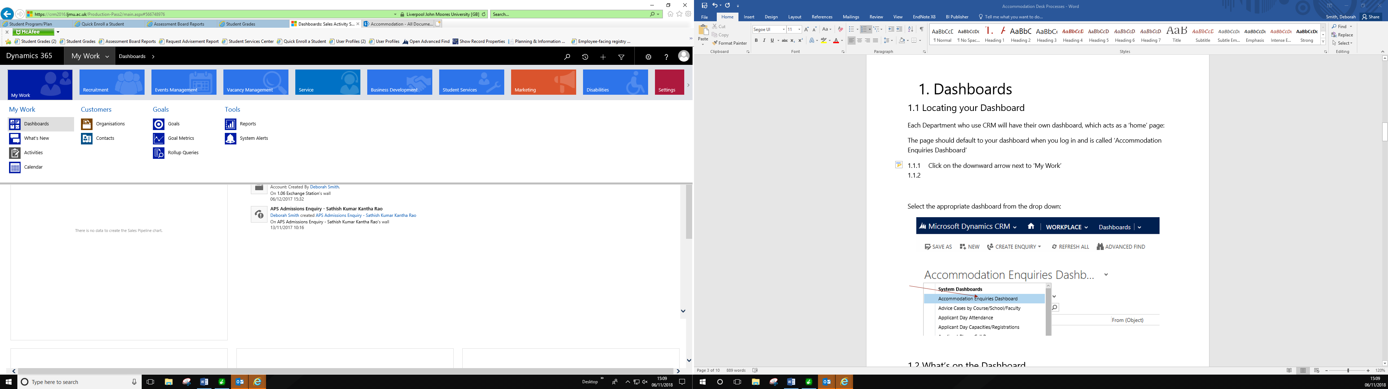

* **Select the Careers SIO View** from the list

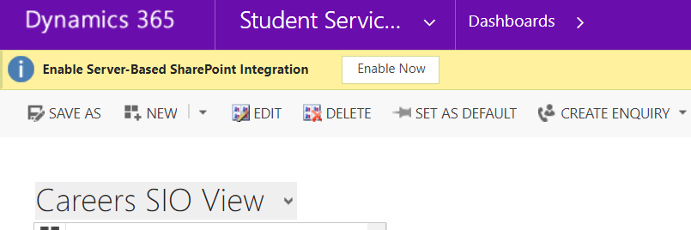

## Pinning a Dashboard

To do this, select the Dashboard, and select **‘Set as Default’**.

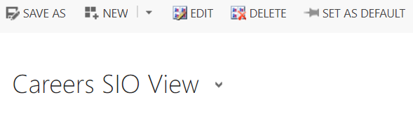

## Views - ‘Pop Out’ Function

You may find the Views within the Dashboard cut off information.

You can ‘pop out’ the view from the Dashboard by clicking on the grid button below:

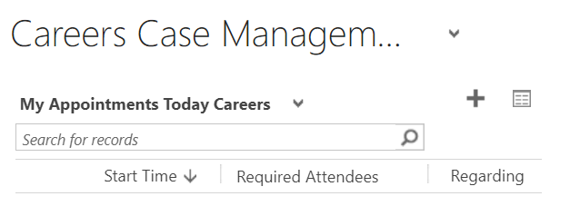

## Sorting

Remember that from within the pop out you can sort or arrange any information by clicking on the headers. You can sort (Ascending, Descending, numerical or alphabetical).

Additionally there is a Search box in the top right where you can search for a student.



# Careers SIO View Dashboard

**The 5 Views are:**

1. **Careers Emails to be Processed**

This is where all new Emails from students will appear. Think of this as your Careers Inbox.

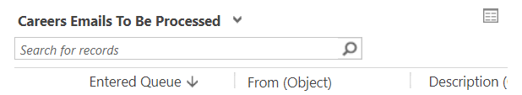

1. **Careers My Actioned Emails**

This is where all Emails you have marked as Worked On will appear. It is essentially a list of Emails which have been dealt with.

# 

1. **My Sent/Pending Emails**

All Emails that have been Sent or have a status of Pending which will require further investigation.

# My Teams Booked 1-2-1 Appointments Careers

These are all Appointments that have already been booked by a Student. They will have either been booked on behalf of the student by your team or the student has booked themselves via the website.

The plus sign can be clicked to add/create a new single or recurring appointment.

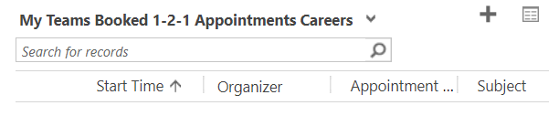

1. **My Teams Available 1-2-1 Appointments Next 12 Months – Careers**

These are all the available appointments over the next 12 months (or however long in advance they have been created on the system). You will be able to see which appointments have been made available on the website ‘ Publish to Site – Yes’.

Again, the plus sign can be clicked to add/create a new single or recurring appointment.

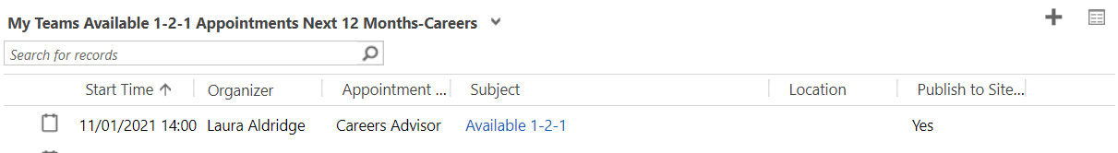

1. **Careers Upcoming Events**

All Upcoming Careers Events can be viewed here.

The plus sign can be clicked to add/create a new Event.

