

Student Information System
Liverpool John Moores University

A Quick Guide to Data Entry for HESA DLHE Return

Version 1.1, 17th January 2013. Created 09th January 2013
Author: David Jones

Note: This is not a training guide

Contents
Contents 2
Overview 3
SIS 3
Help with SIS 3
Handling Issues 3
DLHE 4
DLHE in SIS 4
Supplementary Functionality (Activeweb2/ HESA Validation Kit) 5
Visual Guide to Main Pages 6
Using the System 7
Overview 7
Survey Management (2) 7
Selecting the Return (2) 8
Selecting the Survey Period and Student (2) 9
Searching for Students (2) 9
Searching for Surveys (2) 10
Adding a New Survey (3) 11
Survey Details (7) 12
Entering and Editing Surveys (4) 12
Saving and moving between pages (4) 15
Submitting the Survey (4) 15
Extract Production (5) 17
Validating Extracts (6) 20
Appendix 25
Survey Status (2) 25
Installing Validation Kit (6) 26
Glossary 27
Issues when entering Surveys 28
Time Out Issues 28

Overview
The document provides a user guide for using SIS to enter DLHE survey results to build up a DLHE return. It does not cover setup of the above systems, information on the DLHE process or a guide on how to create the extract to return to HESA, for these topics refer to the Supplementary User Guide, HESA website and Oracle documentation. There are a number of supplementary functions provided by web based applications (activeweb2) and software provided by HESA (the validation kit).

SIS
SIS is LJMU’s student administration system. As part of the functionality the system provides facilities to enter and manage the survey results associated with the DLHE return.
As a whole SIS provides the security model for users; this means SIS determines which users are able to perform a particular task (for example DLHE survey entry) and which data a given user has access to (for example only students of the staff member’s own faculty).

Help with SIS
There is support and material available for SIS generally. This may help with learning to use SIS to complete the DLHE returns.
The support includes SIS Workshops every Tuesday and Thursday. See the university website, where you can book a slot and make enquiries.
The PLN Business Support Website (http://www.ljmu.ac.uk/studentinformationsystem/) provides information on SIS, including guides on administrative processes which might help with understanding SIS more generally.
It may be worth contacting your line manager for arranging either general or specific training.

Handling Issues
Issues relating SIS not being available, errors and issues such as unacceptably short time-outs for the session (i.e. you are logged out after a short amount of time) can be handled be in the first instance contacting helpdesk. There is further information on short time-outs in the appendix.
Depending on availability of Business Support and Business Applications staff you may get a quicker response to issues raising a Helpdesk incident.
Helpdesk can be contacted via the university website (Ask for Help/ Help with IT) or by telephoning 5555 or emailing helpdesk@ljmu.ac.uk describing the issue.
Bear in mind issues can be DLHE specific or more widely related to a problem with SIS.

DLHE
The DLHE survey is a survey of students that have left university to determine their destination (employment, education or otherwise). HESA (Higher Education Statistics Agency) manage the process for the UK as a whole. See the HESA website for examples of what data is collected, the format of the questionnaires and procedures involved with the return.

DLHE in SIS
If you have not used SIS before you will need to be added as a SIS user. Contact Helpdesk or Business Support to have this done.
You may also need to have the security permissions to access the pages you need to perform your DLHE work. These pages can be added to your role in SIS by the person responsible for security in SIS; typically contact Helpdesk or Business Support.
In both instances you can contact the Helpdesk via the university website, telephoning 5555 or emailing helpdesk@ljmu.ac.uk.
SIS should be accessed from the University website staff pages, links to SIS are prominent on the web pages;-
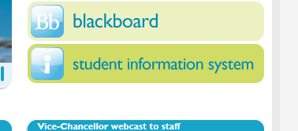
Example of SIS links on main University web pages
SIS will prompt you to enter your University computing account login details. Note in this case it is not required that you may need to prefix your username with ‘users\’. Once logged in you will need to navigate to the pages which provide the DLHE functionality.
- Locations of pages in SIS. The following screenshot shows the menu navigation to access the DLHE pages; -
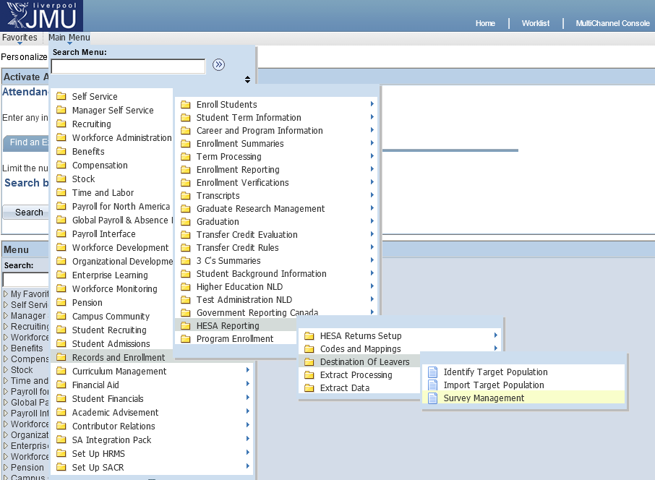
Records and Enrollment >HESA Reporting >Destination of Leavers > Survey Management

Supplementary Functionality (Activeweb2/ HESA Validation Kit)
The DLHE web application on activeweb2 provides facilities to produce record extracts for students individually. This allows the individual student records to be checked as they are entered.
The individual record extract is checked using the HESA Validation kit, which is a piece of software which is used to check the survey returns against structure and business rules.
Both the above functionalities are not provided by SIS currently.
Visual Guide to Main Pages (Numbers in document titles refer to the numbers used here)

Using the System
The various pages used for DLHE are summarised in the diagram a ‘Visual Guide to Main Pages’. The majority of the DLHE tasks can be accessed from the survey management page.

Overview
Entering a survey response for a student’s return involves the following steps, numbers referring to the appropriate parts of the guide are included) ;-
- Logging on if not already logged on to SIS, (1)
- Navigate to the DLHE Survey Management page (2), which gives access to;
- Add a new survey (Add a Survey page) using the emplid, save the new survey (3)
- Search for the new survey (Survey Management Page) (2)
- Enter the data for the survey (new window or tab), saving between sections (4)
- Generating and downloading the extract for the single record using activeweb2 (5)
- Validating using the HESA validation Kit (6)
- Making any changes to the survey required from the results of validation (4)

Survey Management (2)
The survey management page is central to the SIS DLHE system. Navigate to the following location to show the survey management page; -
Main Menu > Records and Enrolment > HESA Reporting > Destination of Leavers > Survey Management
This page allows you to; -
- choose which return to work with
- choose which survey to use (January or April)
- get access to the page to add new surveys
- search for existing surveys
- access existing surveys once you have searched for them
- see the details for existing surveys once you have searched for them
- change the status of surveys once you have searched for them
The Survey Management page is shown below;-
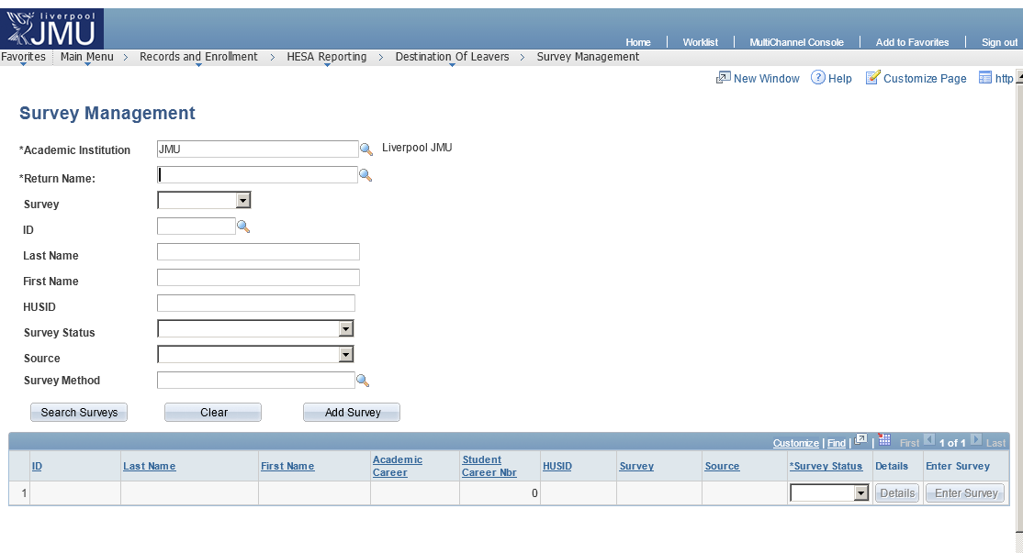
Survey Management: Fields marked with an asterisk* are required and must be filled in to perform a search.
The Academic Institution (JMU) is already selected for you in the page shown above. If you simply want to add a new record it may be appropriate to click ‘Add Survey’ immediately.

Selecting the Return (2)
The Return Name can be selected using the lookup to the right of the ‘Return Name’ field. Something similar to the following will be displayed; -
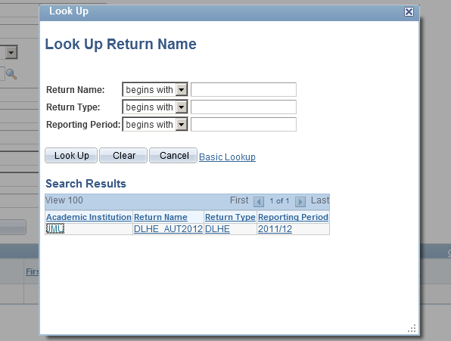
Return look up: Select the return you wish to work with.

Selecting the Survey Period and Student (2)
Select the correct Survey by clicking the corresponding row in the Search Results.
The correct Survey (January or April) can be selected.
If you are searching for an individual record for a student, the student ID can be selected as well (see the next step for more detail); -
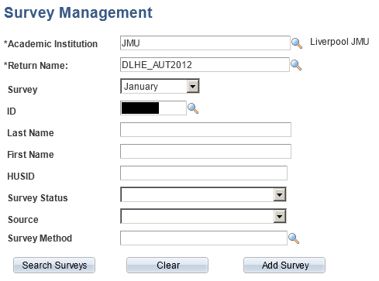
Survey Management: Fields marked with an asterisk* are required and must be filled in to perform a search.

Searching for Students (2)
The ID for a student (known as the emplid, student number in SIS) can be entered directly if you know it. Otherwise, the look up, can be used to find a student. This contains all students on the system and may take a LONG time to appear. It is much better to type directly the student number from the address label on the paper survey.

Searching for Surveys (2)
Once the required* information has been entered in the Survey Management screen and any extra information to narrow the search is entered, the ‘Search Surveys’ button can be used to search for surveys.
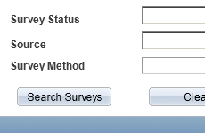
Above: The ‘Search Surveys’ Button
If there are matching surveys they will be displayed at the bottom of the page; -
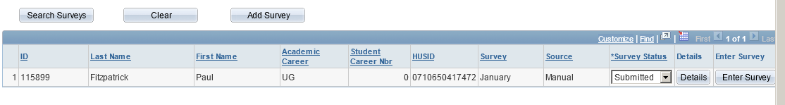
The results allow the status of surveys to be changed, the details of a survey to be viewed and the survey to be edited.
For each survey record (a row in the results); -
- The ‘Details’ button on a result row allows the viewing of a corresponding surveys details.
- The ‘Enter Survey’ button will bring up the survey in a new tab or window, allowing it to be edited.
Adding a New Survey (3)
A survey can be added by clicking the ‘Add Survey’ Button in the Survey Management(2) screen. A new survey for the student will be created.

The following page will be displayed and can be mostly filled in with the lookups which help restrict options to those relavent to the selected student;- 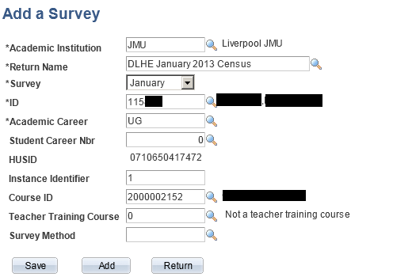
When you have finished entering details click the ‘Save’ button. The ‘Add’ button allows additional Surveys to be added, but you will need to save the new survey you have just entered first. The ‘Return’ button returns to the Survey Management page.
The magnifying glass (look up) icons are links which allow the correct values to be looked up for each field. In many cases there will be just a single value; meaning the system has found the correct value and you just need to confirm you are using it. Again the student ID field can take a long time to return results.
Once you have created the surveys you need then return to the Survey Management page to enter/input data into the surveys.

Survey Details (7)
The ‘Survey Details’ button against each survey result on the Survey Management page provides the survey details page for that student; -
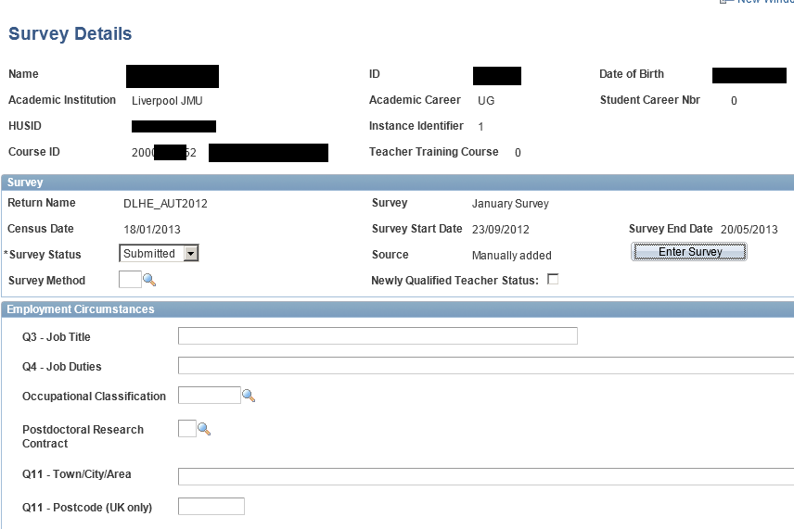
Above: Survey Details screen.
This page allows a summary of the survey to be seen. In addition the ‘Enter Survey’ button allows the survey to be opened as in the section below.
The ‘Return’ button takes you back to the Survey Management page.

Entering and Editing Surveys (4)
The system provides pages to enter the survey question results. A page per section (A, B, C, D, E and F) is provided as the previous system did on activeweb2.
N.B. The Survey pages are launched in a new tab or window depending on your browser
At the top of each page there is the basic information relating to the student.
Examples of these pages are shown below; -
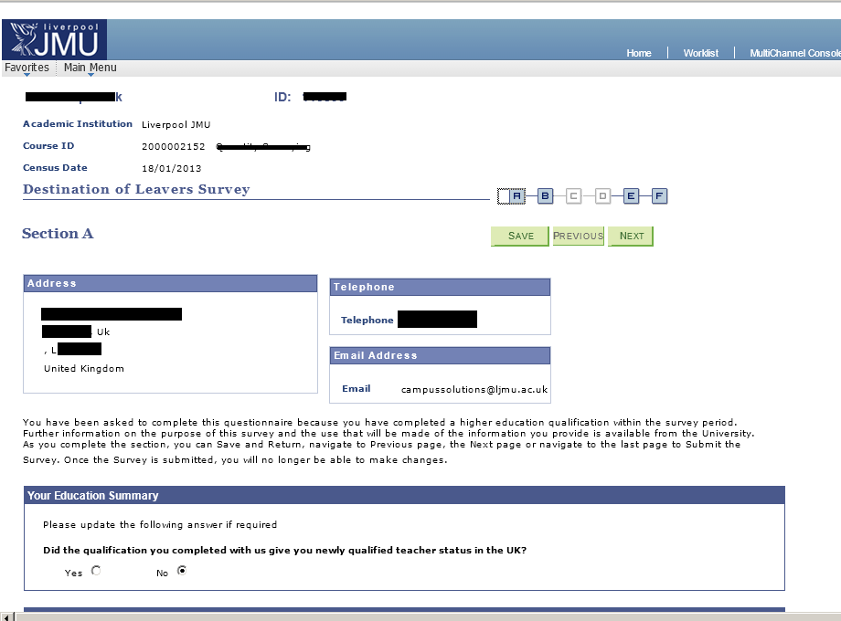
Above: Screenshot of the page for Section A
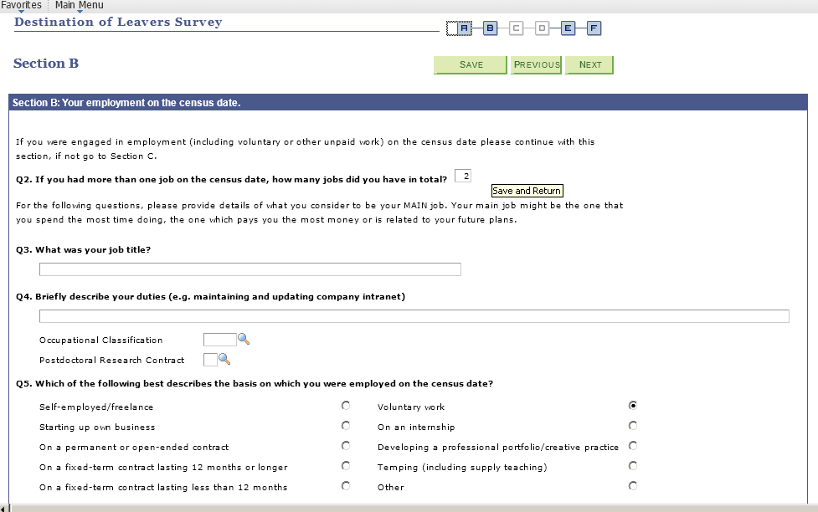
Above: Screenshot of the page for Section B
Using Look ups
For fields in the survey with a magnifying-glass icon next to them, look ups are available by clicking the icon. These provide a dialog listing possible values for the field. One example is the Occupational Classification.
The lookup provides possible Occupational classifications. These can be filtered down by using a keyword as a search term in the ‘Long Description’ search box. The type of search can be changed from ‘Begins with’ to ‘contains’ which will be less restrictive. Try to type small phrases or fragments of words. As an example, in the example shown in the image below, typing ‘careworker’ would return no results.
If a particular result is the correct one it can be clicked and used as the value in the field. Clicking anywhere on the row is fine.
Clicking a heading (Field, Code, Description, Long Description) sorts by the respective column.
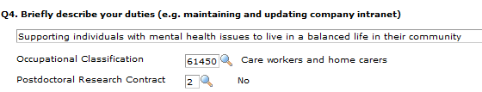
The question (above) and the Look Up (below);- 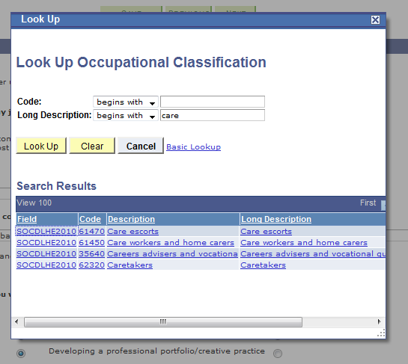

Saving and moving between pages (4)
At the top and bottom of the survey entry pages are the following controls; -
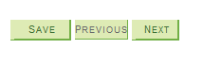
The Save button is used to save the survey information you have entered. Do this regularly.
The Previous and Next buttons allow navigation to the previous and next sections respectively.

Submitting the Survey (4)
Section F has different controls. Once you have finished entering data and have saved, click the Submit button to submit the survey. You can now close the tab or window which contains the survey.
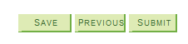
In addition section F provides a summary of the survey sections, indicating which questions are incomplete. Whilst this is not a proper validation it may give an idea as to the state of the survey.
If SIS believes all questions for all sections have been filled in then the Incomplete Questions column will be blank.
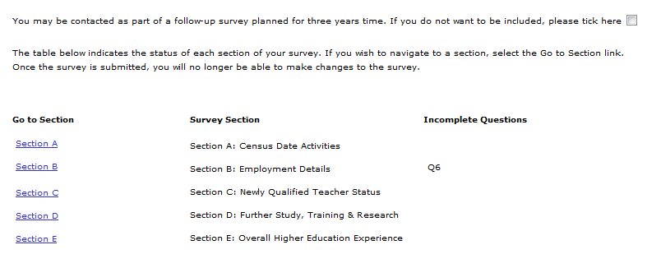
Sections Status Summary in section F, showing the Incomplete Questions column

Extract Production (5)
The production of DLHE Extractions is via a web application at; -
https://activeweb2.ljmu.ac.uk/DLHE/pages/Welcome.aspx
You may need to provide your login details. In this case you may need to prefix you username with ‘users\’.
The Web Application provides a means of extracting individual survey records (corresponding to individual student’s returns) from the SIS system. This facility is not available within SIS; hence it is provided by the LJMU HESA DLHE system.
On the first page the ‘SIS Support 2012 onwards’ should be the survey period selected; -
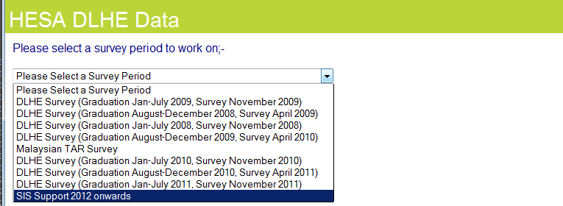
Selecting the correct survey period
The Main page is shown below; -
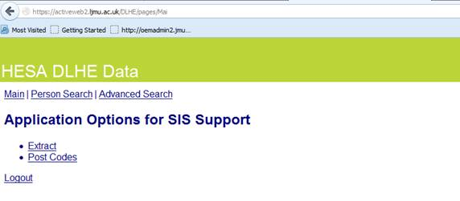
Click ‘Main’ from the links and then ‘Extract’. The search should be using the person number/ SIS emplid and not the HUSID. The emplid is a six digit number.
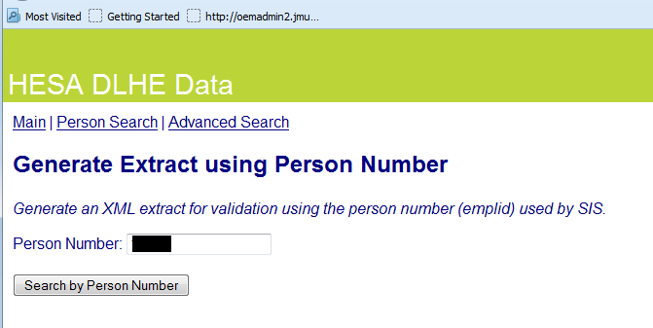
Entering an emplid to generate an extract
The results are shown and made available for download to feed into the validation kit; -
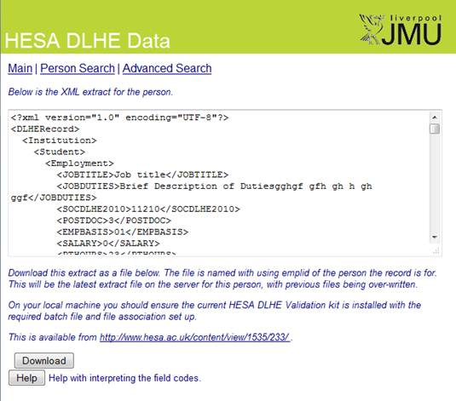
Click the ‘Download’ Button and save the extract when prompted. The extract should be saved somewhere you can easily find it. The ‘downloads’ facility of your web browser may well show where the file has been saved to. It will be saved with a filename containing the emplid of the student that is the subject of the record.
If you download multiple extracts for the same record you may find your browser appends ‘(1)’ to the filename for the second copy, ‘(2)’ for the third and so on. Make sure you validate against the latest copy of the file.
You now have the extract ready for validation.
The file is in text XML format and maybe opened with a text editor.

Validating Extracts (6)
One validation kit is used for all HESA extracts now including DLHE. If you are using an LJMU Windows 7 client the validation kit will be available via the JMU App Player. Otherwise the validation kit will need installing; see the appendix and HESA website for details.
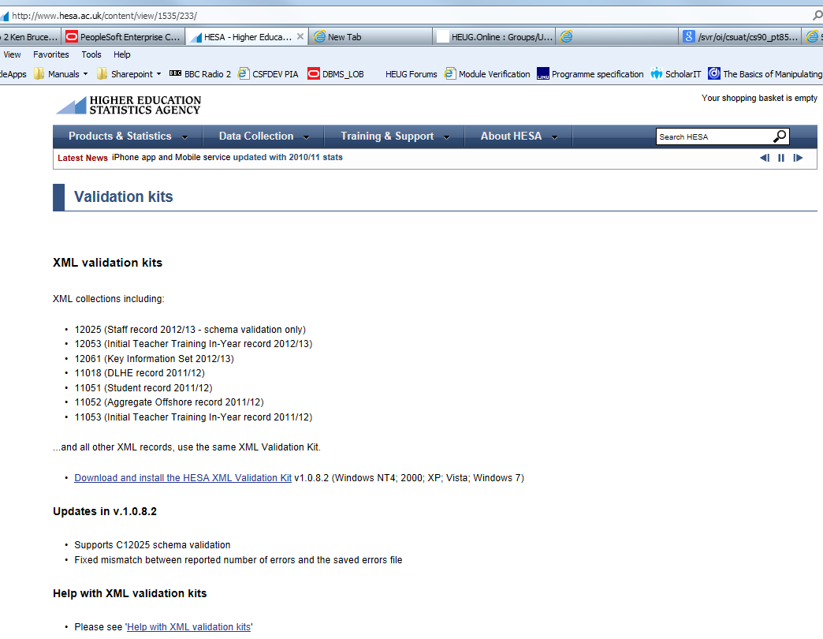
DLHE pages on HESA Website
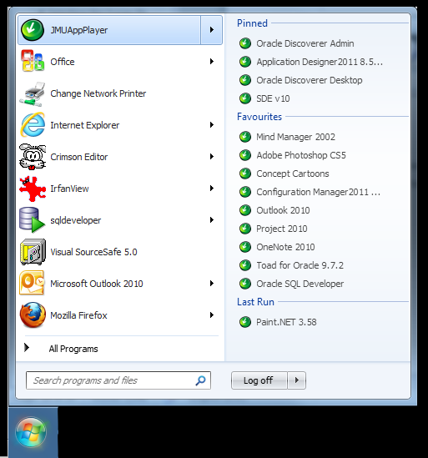
The JMUAppPlayer link on a Windows 7 client machine
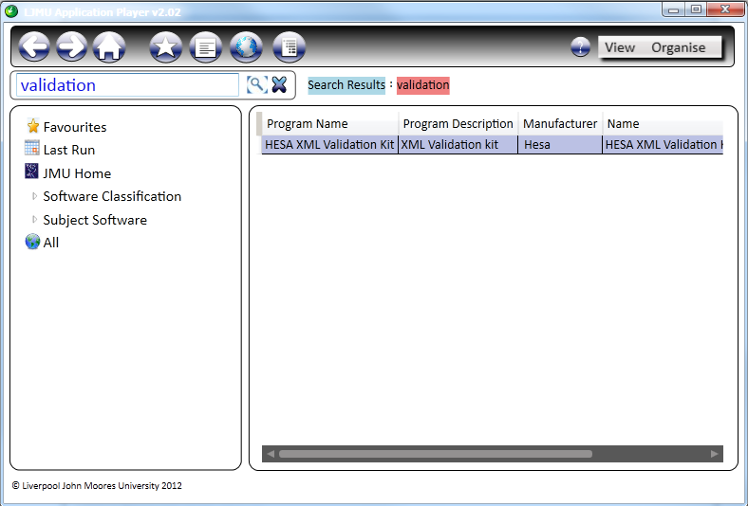
Above: the HESA XML Validation Kit as made available through the LJMU Application Player
The application main screen is as follows; - 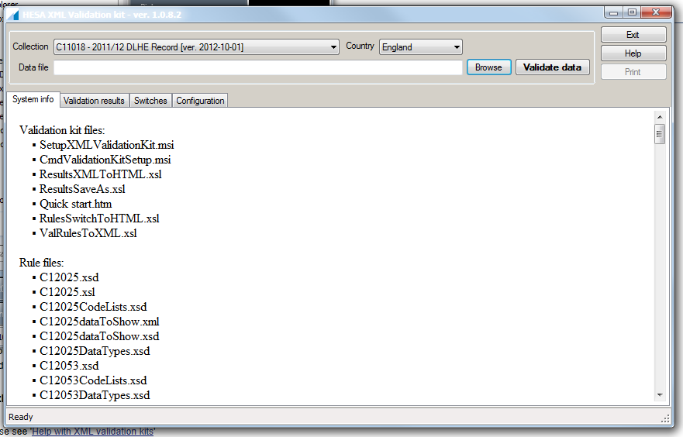
Validation Kit main screen
The ‘Browse’ button allows you to select the file containing the extract to validate. This will be the file you have downloaded from activeweb2. The name and location of the file will be displayed in the ‘Data File’ label to the left of the Browse button .
The ‘Validate data’ button validates the extract file. The results are displayed in the ‘Validation results’ tab part of the set of tabs which forms the main part of the window.
You may need to select the correct ‘Collection’ from the drop down menu at the top of the window. Chose the correct collection for the DLHE period you need to validate for.

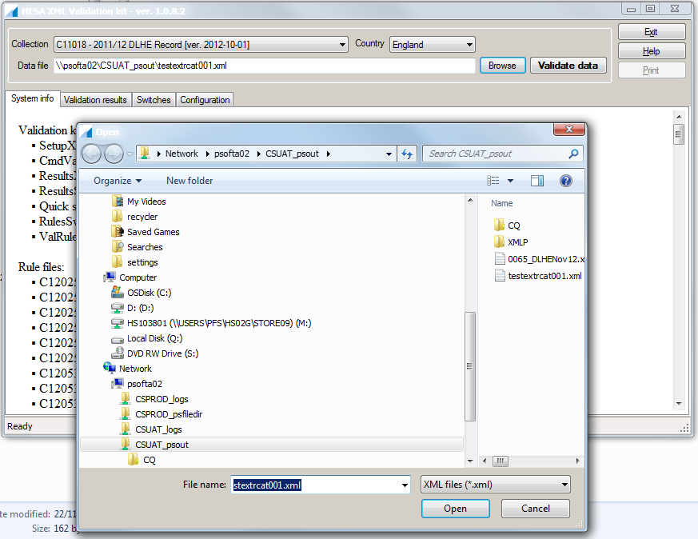
Selecting the extract file using the Open dialog shown by the Browse button. The file will be found in the location at which your web browser saved it to.

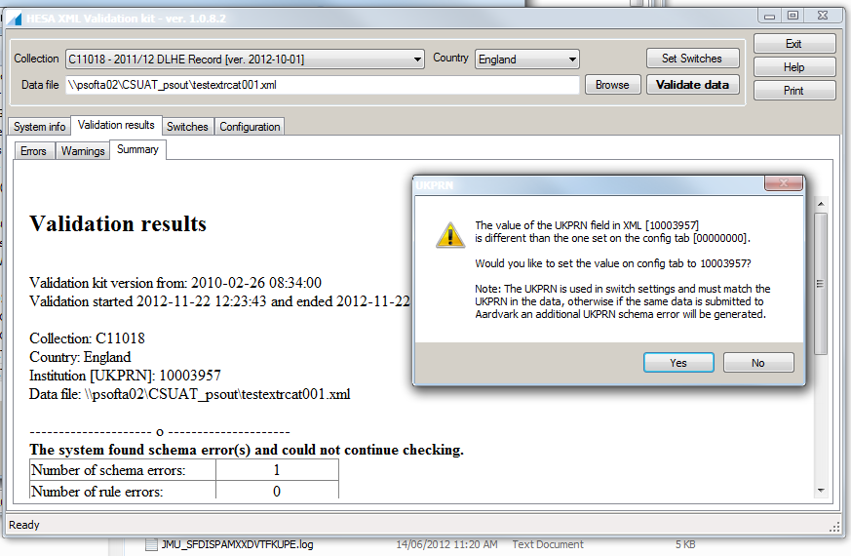
Validation results are displayed in 3 tabs of Errors, Warnings and Summar. In addition a prompt for UKPRN value may appear if you have installed the program yourself.

Appendix

Survey Status (2)
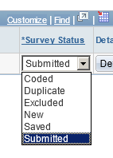
The survey can have one of the following Status’;-
The Survey Status’ are quoted below from the (GBR) Using DLHE Self-Service Survey ; -
Status | Description
New | This status indicates that a student DLHErecord has been created, but no survey data has been stored. This status allows an administrator or student to access the survey to input responses.
Saved | A record with a status of ‘New’ moves to ‘Saved’ once survey responses have been entered and the user clicks the Save button. This status indicates that the survey is incomplete and the user expects more information to be input. This status allows access to the user to previously saved surveys.
Submitted | The user indicates that they have completed the survey and wishes to submit their answers by clicking the Submit button. Once a survey is in a status of’Submitted’,it is closedto the student and only the administrator can add further responses.
Coded | For administrative use only. This status is used to indicate survey records that are complete. This indicates that the record has been reviewedby an administrator and is ready for extraction.  For surveys entered by administrators, the status would change from either ‘New’ or ‘Saved’ to’Coded’ once the manual survey process hasbeen undertaken and the survey was deemed complete.  For surveys entered via student self-service, an administrator would change ‘Saved’ or ‘Submitted’ surveys to’Coded’ once additional coding had been done and the survey was deemed complete.
Excluded | For administrative users only. This status is used to indicate records that should be excluded from the survey population. The survey responses are retained.
Duplicate | For administrative users only. This status indicates records should be excluded from the survey population. Survey responses already recorded are retained and not deleted.

Installing Validation Kit (6)
In addition to this appendix see the HESA Website and/ or the Supplementary User Guide.
You will need to install the HESA validation kit yourself (or have it installed) if you are using a non-Windows 7 LJMU client or a non-LJMU machine.
LJMU Windows 7 clients have the HESA XML Validation kit available on the LJMU Apps Player and the following procedure isn’t needed.
Firstly download and run the HESA XML Validation Kit from the HESA Website (www.hesa.ac.uk). The download can be found via the DLHE pages.
DLHE Collection page showing link to validation kit page; -
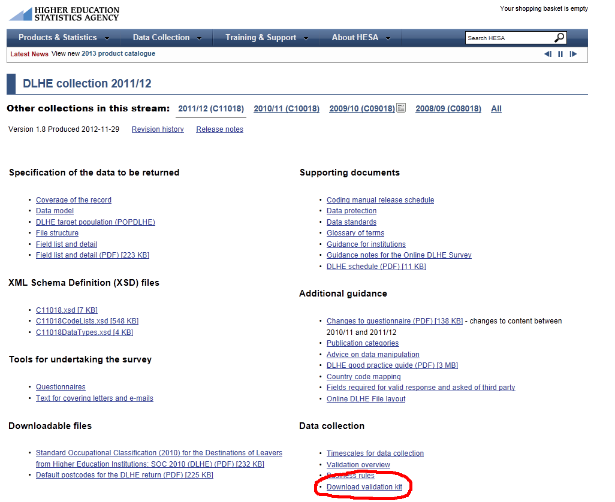
Download link on the validation kit page;-
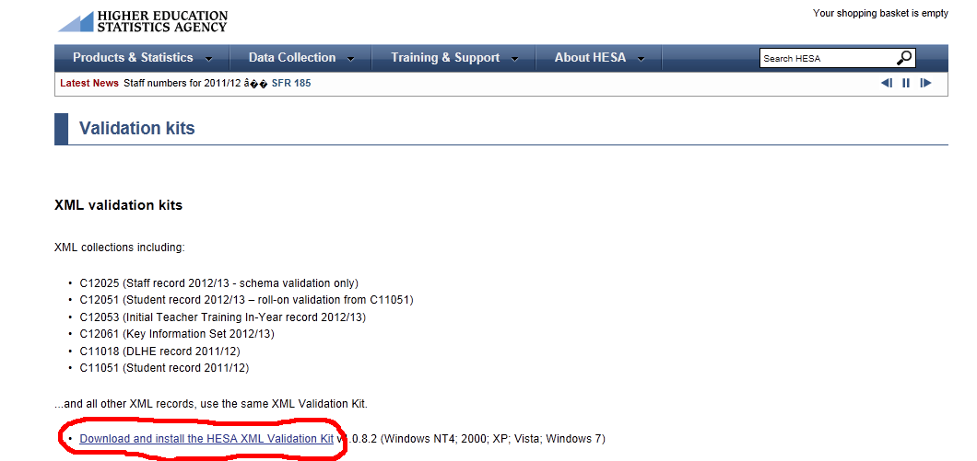
Run the installer either directly or by finding the file in your download folder and running it there.
Follow the installer ‘wizard’ steps for installing the application.
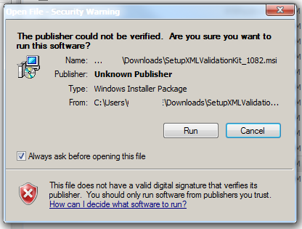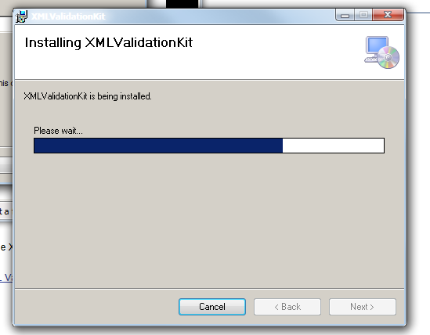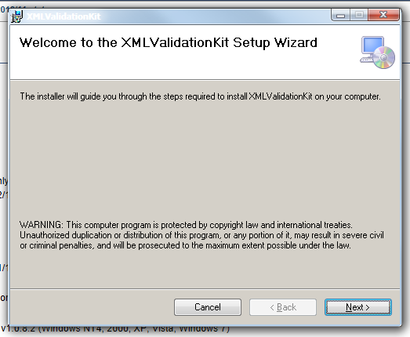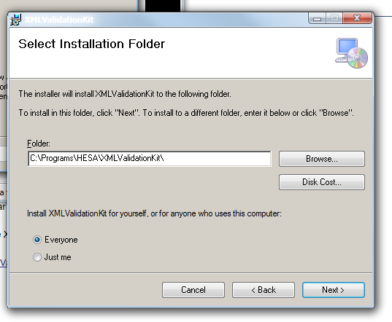
Images; -
Top left: The software publisher warning (HESA does not have a digital signature for the validation kit). Top right: installation progress. Bottom left; the welcome screen. Bottom right; installation options. You may need to change the install path to the D: drive (for example: D:\Programs\HESA\XMLValidationKit\). Depending on your machine you may or may not see the ‘Everyone’ or ‘Just me’ options.
After installation is complete you will then find a link to the program in the Programs menu of your Start Menu.

Glossary
Emplid – is the term used to identify a person in SIS. Emplid can be a person or student. For most DLHE cases emplid will refer to a student. The term/word is due to the HR origins of PeopleSoft which is what is used to build up SIS.

Issues when entering Surveys
  - Teaching Courses; when the survey record is created whether the course is or isn’t a teaching course is chosen. This answer appears unchangeable later on.
  - Refreshing the Survey Management Page. After entering a survey refresh the results of the Survey Management page to prevent seeing errors.
  - Students missing out item corresponding to main reason. If a student has not indicated an option as a reason when they have selected the same option as a main reason, simply select it as a reason as well.

Time Out Issues
In the event of the system having unacceptably short time-outs for the session (i.e. you are logged out after a short amount of time) contact helpdesk on telephone 5555 or helpdesk@ljmu.ac.uk.
We anticipate the performance of csprod (production) to be a lot better than csuat (user acceptance testing) in this respect.
You will need to state the system either live (csprod) or testing (csuat). Also what you were doing at the time and the approximate length of time you were logged in for may be useful.
Normal timeouts will be around 60 minutes. It is preferable to save your work as you proceed and definitely before you leave a machine for a long period of time.
Session time out screen; -
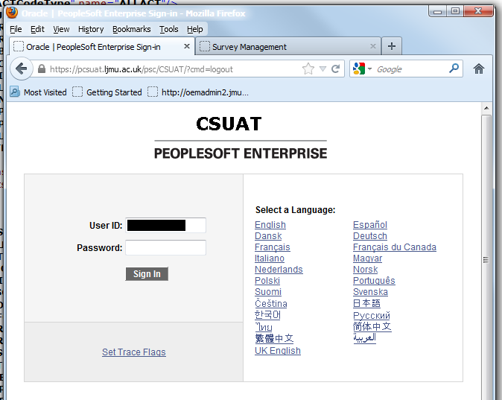
Attempting to login again via the above page may result in; - 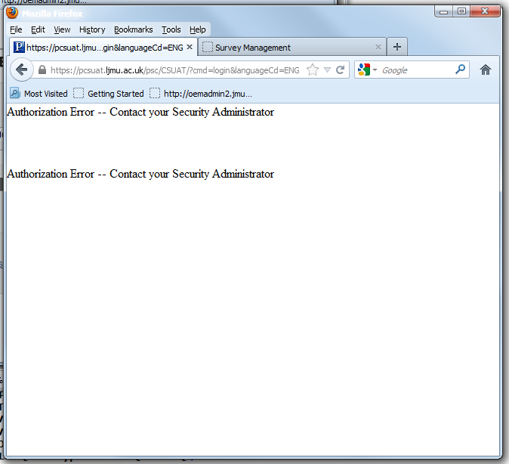
At this point you are advised to restart your web browser and navigate back to the SIS login page.

