Request for Quotation (RfQ)
Ref: LCEI-LJMU- 043
N.B. This Request for Quotation (RfQ) is being promoted by Low Carbon Eco-Innovatory (LCEI) on behalf of the company stated below as part of their assistance through the UKSPF-funded LCEI project. The company will be solely responsible for all scoring and decision-making processes.

Name of item/system required |  | P.V. Solar array panels for install on the roof of the Warehouse (A Block)
Company Name | Peter Gilding & Co Ltd
Address | Caddick Road, Knowsley Business Park, Prescot, Merseyside, L34 9HP
- Background
Peter Gilding & Co. Ltd are a family owned, fresh produce company, established in 1986, who purchase produce from both northern and southern hemispheres. We store on site in our Knowsley cold store and distribute to wholesale and supermarket customers throughout the UK.
Our product portfolio includes deciduous (apples & pears); citrus (oranges, easy peelers, lemons, limes, grapefruit); stone fruit (plums, cherries, peaches, and nectarines); grapes; melon; and exotics (kiwi and avocado). The fresh produce is sold to wholesale markets e.g., Glasgow, Bristol, Covent Garden.
We operate a Pack House facility on site and pack fruit into retail packs for supermarkets. Typical packed produce can include apples, pears, citrus, kiwi etc.

Following support from LCEI to decarbonise their business, this item has been identified and funding allocated towards the purchase by the business.
- Requirement:
Solar system expected to be in the region of 450 KwP (will depend on outcome of the design phase) [approx. 1100x PV modules of 415w each, 5x Inverters, 500x optimisers]

A detailed list of the anticipated works required is included as Addendum 1 to this Request for a Quotation* (RFQ). [*Remove this section if not applicable]
- In your quotation, please provide evidence of your company’s ability to;
- Demonstrate value for money (costs):
- Be able to complete the project by 15th January 2025 in line with LCEI funding regulations:
- Meet the specification of the required item/provide a suitable warranty:

- Provide a Project Delivery Methodology:
- Detail why your product is deemed suitable to the company and their requirements specified:

- Sustainability/ESG credentials of your business operations and more specifically about the product:

- Provide testimonials:

Please advise in your quotation if a physical visit, by how many people and for how long, to the nominated premises is required to undertake the described work.
- Deliverable Timescale:
It is anticipated that this project will commence in |  |  | [ASAP]
And be completed by |  |  | 15/01/2025

- Indicative Budget:
Between £200k and £300k
- Evaluation Criteria: Quotations will be assessed and scored on the following criteria:
- Cost/Value for money (25%): Does supplier offer value for money. This will not necessarily be the cheapest quote.
- Delivery Timescale (25%): Supplier must demonstrate they can deliver the requirement to timescales above.
- Specification/Warranty (20%): Supplier must meet the specification as detailed above.
- Project Delivery Methodology (10%): Supplier must demonstrate a detailed and professional approach to the project.
- Quality/ Technical Merit (10%): Supplier must demonstrate they have the technical and professional capability to deliver the requirement.
- Sustainability/ESG (5%): Show commitment to decarbonisation.
- Testimonials (5%): Supplier must demonstrate successful outcomes on similar projects

- Scoring Methodology
4 Excellent | Proposal meets and, in some places, exceeds the required standard
3 Good | Proposal meets required standard
2 Acceptable | Proposal meets the required standard in most respects, but is lacking or inconsistent in others
1 Poor | Proposal falls short of expected standard
0 Unacceptable | Completely or significantly fails to meet required standard or does not provide the relevant answer

- Proposal Format:
Your proposal should clearly demonstrate how it meets the requirements set out above.
Please provide details of any sub-contractors you will use to deliver this work.
- Deadline and Submission:
Completed quotations responding to this RFQ must be e-mailed to:  Email subject must include the RfQ Code LCEI-LJMU- 043 |  | Nick@petergilding.co.uk AND  EcoInnovatory@ljmu.ac.uk
No later than 17:00 Greenwich Mean Time on: |  | 20/09/2024
Date Published: | 06/09/2024
This work is part funded though UKSPF Low Carbon Eco-Innovatory (LCEI). LCEI is a partnership between Liverpool John Moores University and University of Liverpool, funded by the UK Government through the UK Shared Prosperity Fund with the Liverpool City Region Combined Authority as the lead authority.

Conditions of Tender:
Please be aware that there is no regulatory obligation for us to provide feedback if you are unsuccessful.
We reserve the right to discontinue this tender process at any time and not award a contract.
You will not be entitled to claim from us any costs or expenses which you may incur in preparing and/or submitting your Tender at any stage of this exercise. This applies whether or not your organisation is successful.

Addendum 1

System to be split to feed into two separate MPANs in the below building
Addendum 2.
To fill the south facing orientated roof of the building below on Caddick Road, L34 9HP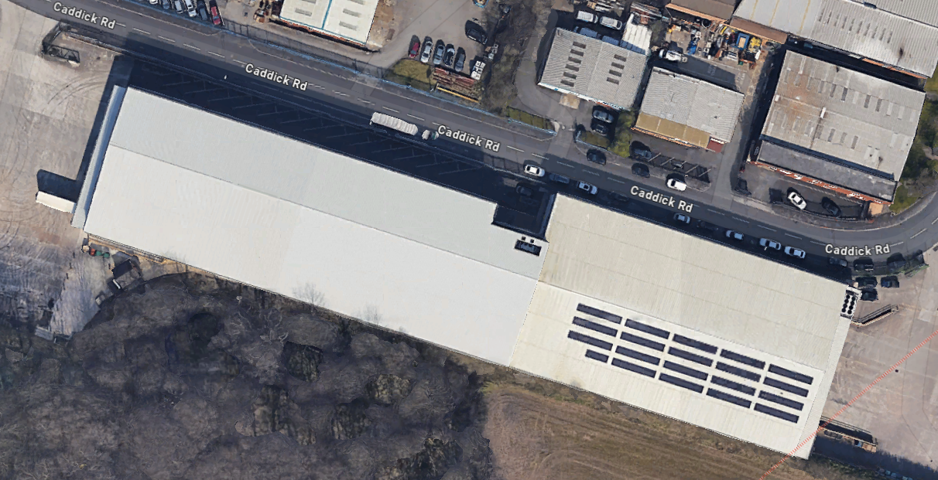
Project Title:

Work Package Stages: [Break down your requirements into main stages/tasks…]

https://www.ljmu.ac.uk/microsites/low-carbon-eco-innovatory/
https://www.ljmu.ac.uk/microsites/low-carbon-eco-innovatory/lcei-grant-scheme

